**📋 ASSIGNMENT REPORT**

**Setup Verification**

**Screenshot 1: PyCharm with WSL Interpreter**

Screenshot showing PyCharm with WSL configured as the Python interpreter.

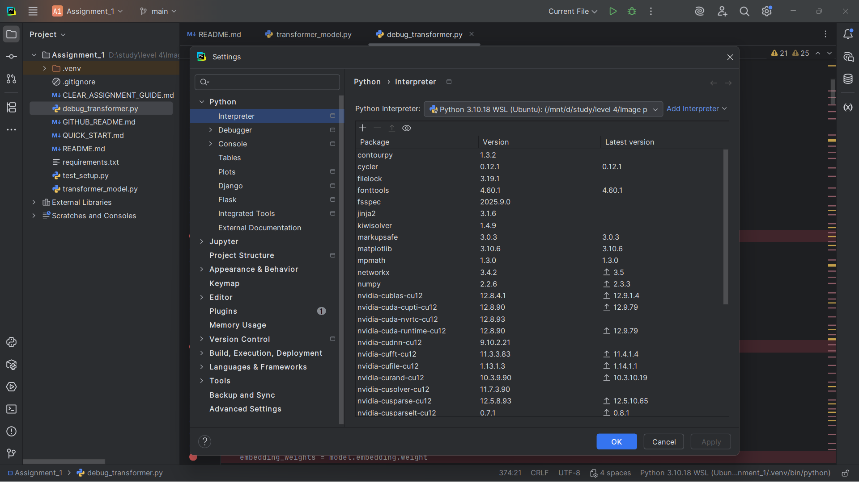

**Screenshot 2: Successful Model Run**

Screenshot showing the model running successfully in PyCharm.

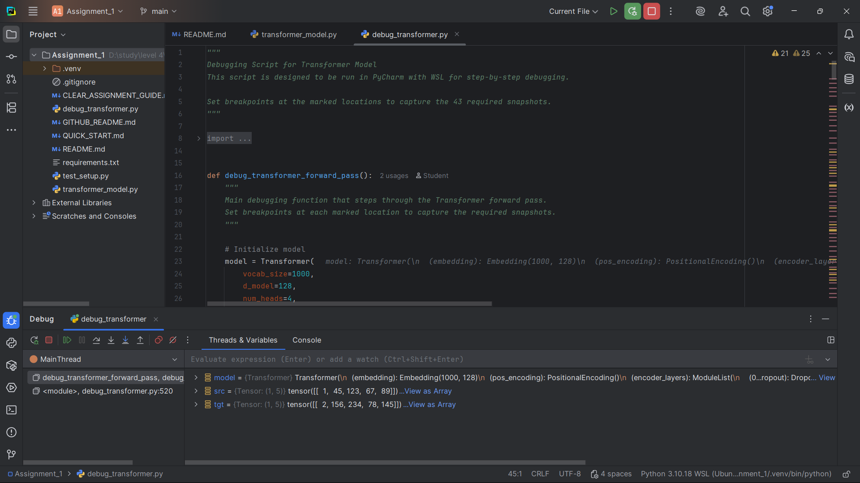

**Snapshot Analysis (43 Screenshots Required)**

**Snapshot #1 – Raw input tokens**

**Expected Shape**: (1, 5)

**Expected Values**: [1, 45, 123, 67, 89]

**Explanation**: These are the token IDs representing the input sequence "The quick brown fox" before any processing.

[Snapshot #1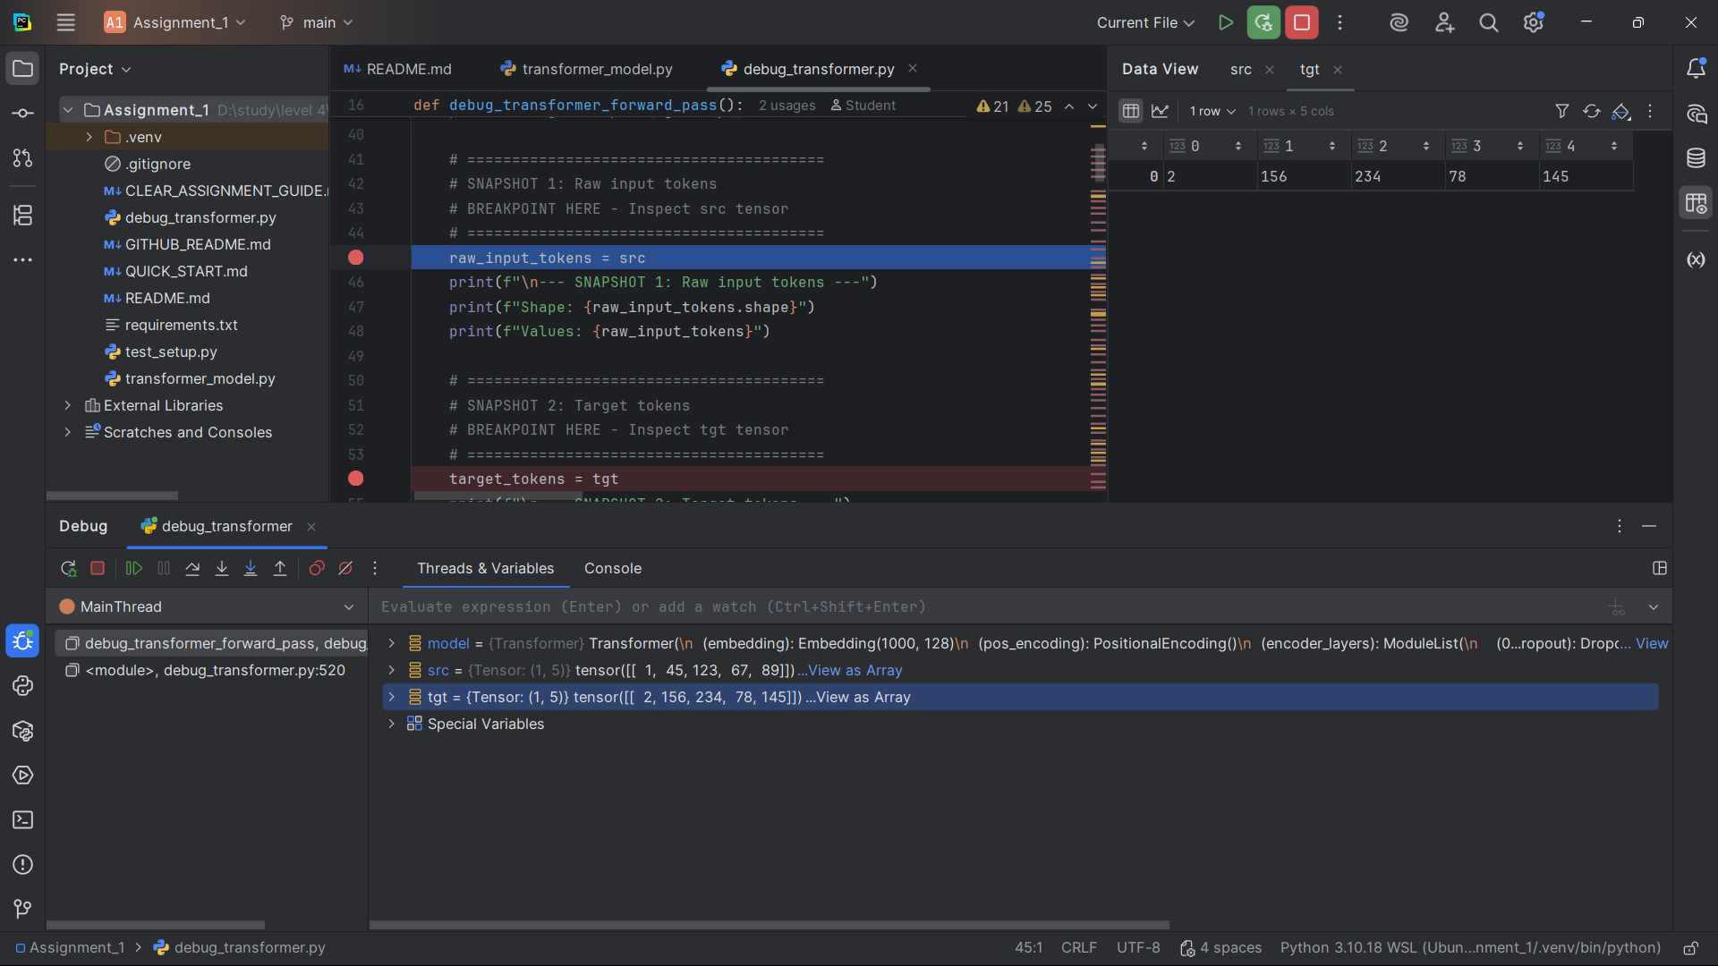]

**Snapshot #2 – Target tokens**

**Expected Shape**: (1, 5)

**Expected Values\*\***: [2, 156, 234, 78, 145]

**Explanation**: These are the token IDs representing the target sequence "Le renard brun rapide" for translation.

[Snapshot #2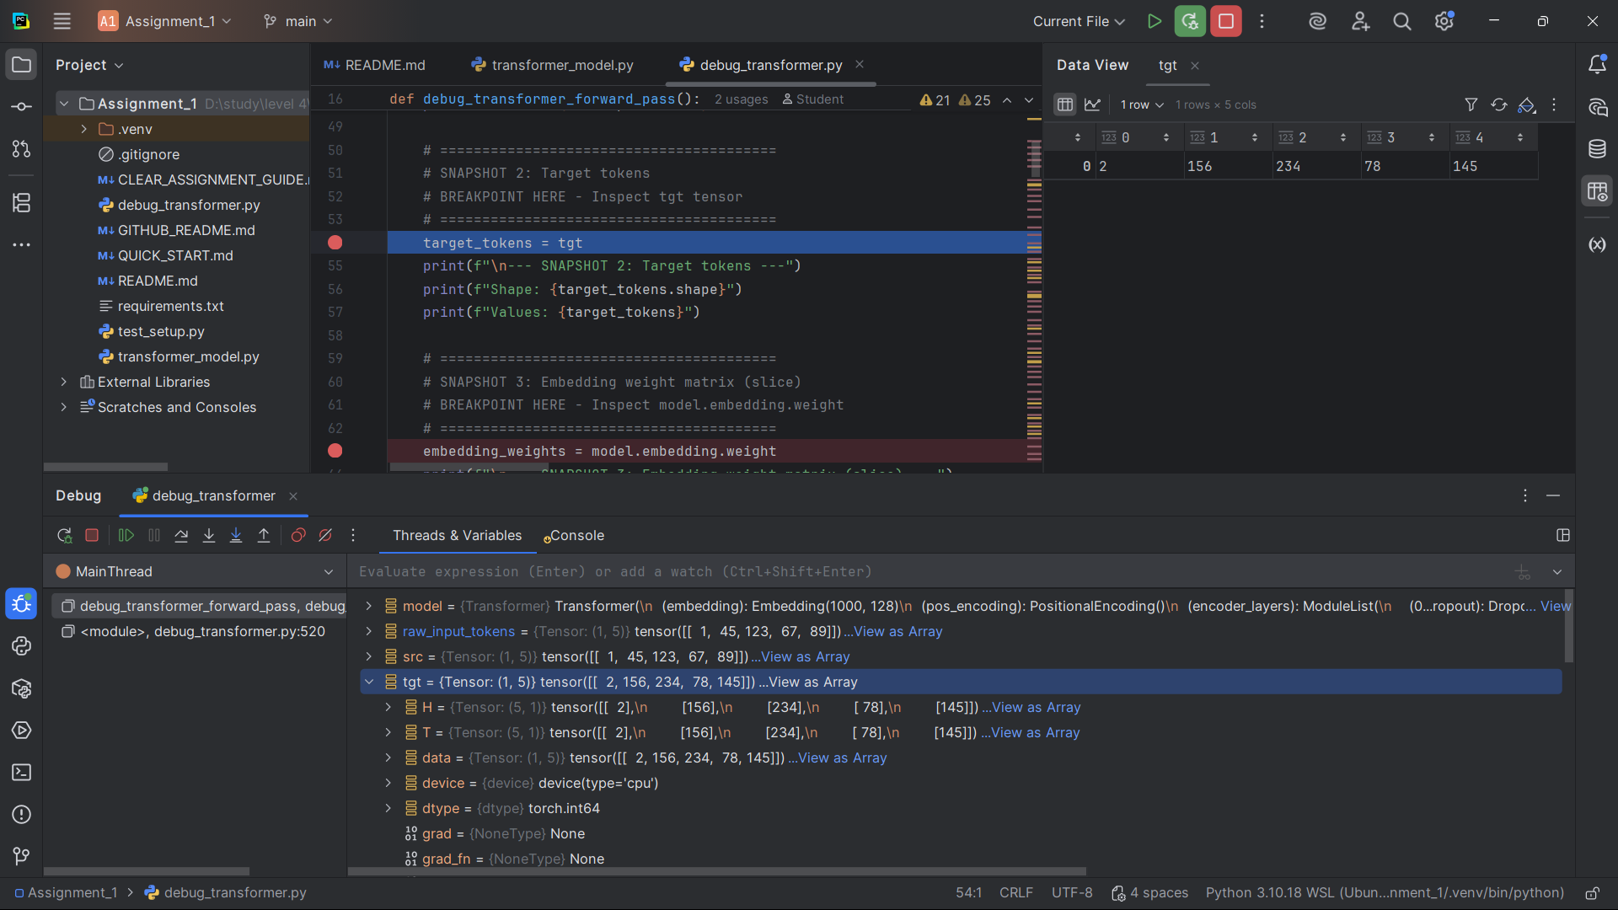]

**Snapshot #3 – Embedding weight matrix (slice)**

**Expected Shape**: (1000, 128)

**Expected Values**: 5x5 slice of embedding weights

**Explanation**: This is the learned embedding matrix that converts token IDs to dense vectors. The slice shows the first 5 tokens' embeddings.

[Snapshot#3

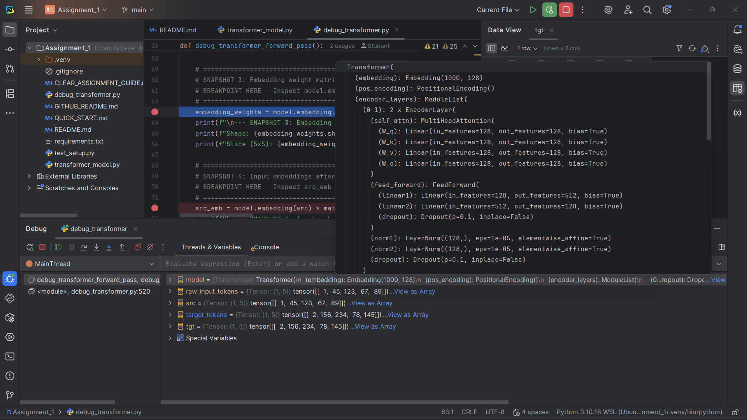

Snapshot#3.2

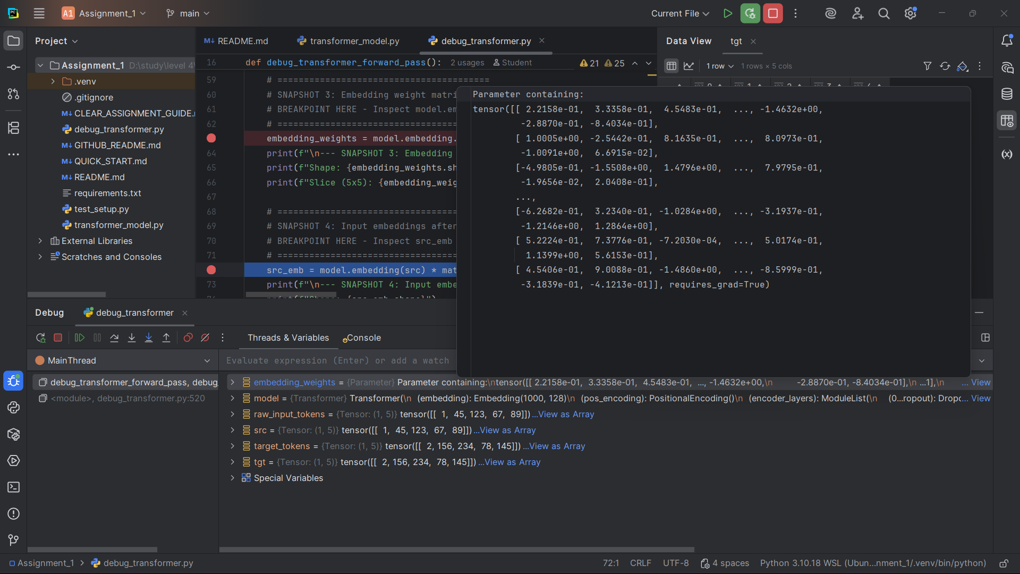

]

**Snapshot #4 – Input embeddings after lookup**

**Expected Shape**: (1, 5, 128)

**Expected Values**: Dense vectors for each token

**Explanation**: After looking up token IDs in the embedding matrix, we get dense vector representations for each token.

[Snapshot #4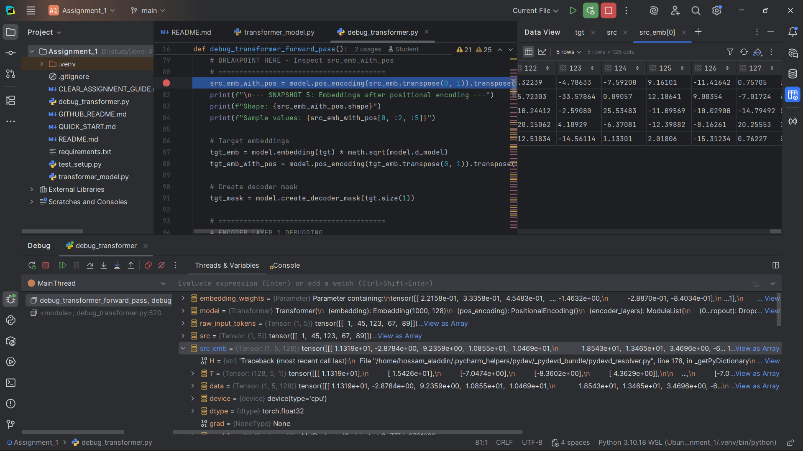]

**Snapshot #5 – Embeddings after positional encoding**

**Expected Shape**: (1, 5, 128)

**Expected Values**: Embeddings with position information added

**Explanation**: Positional encoding is added to help the model understand the order of tokens in the sequence.

[Snapshot#5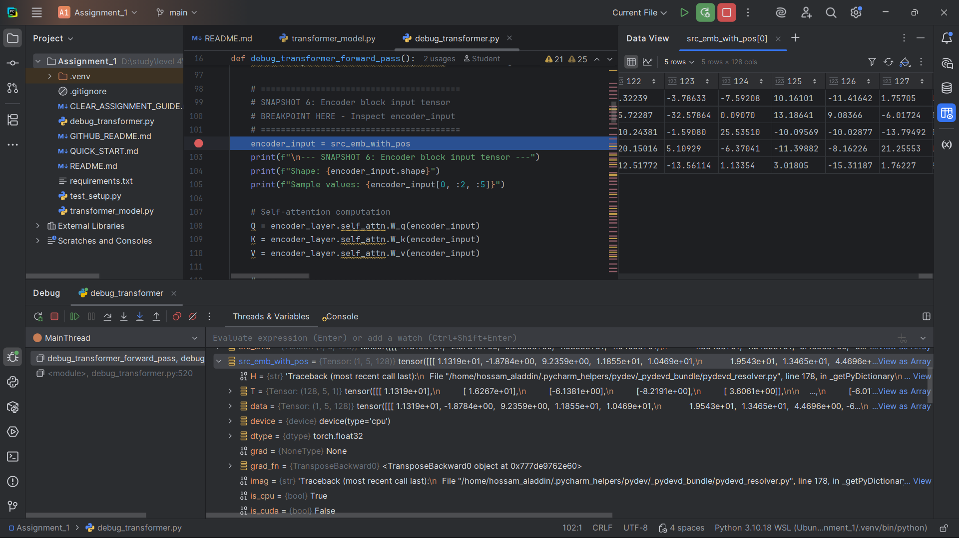]

**Snapshot #6 – Encoder block input tensor**

**Expected Shape**: (1, 5, 128)

**Expected Values**: Input to the first encoder layer

**Explanation**: This is the input tensor that will be processed by the encoder's self-attention mechanism.

[Snapshot#6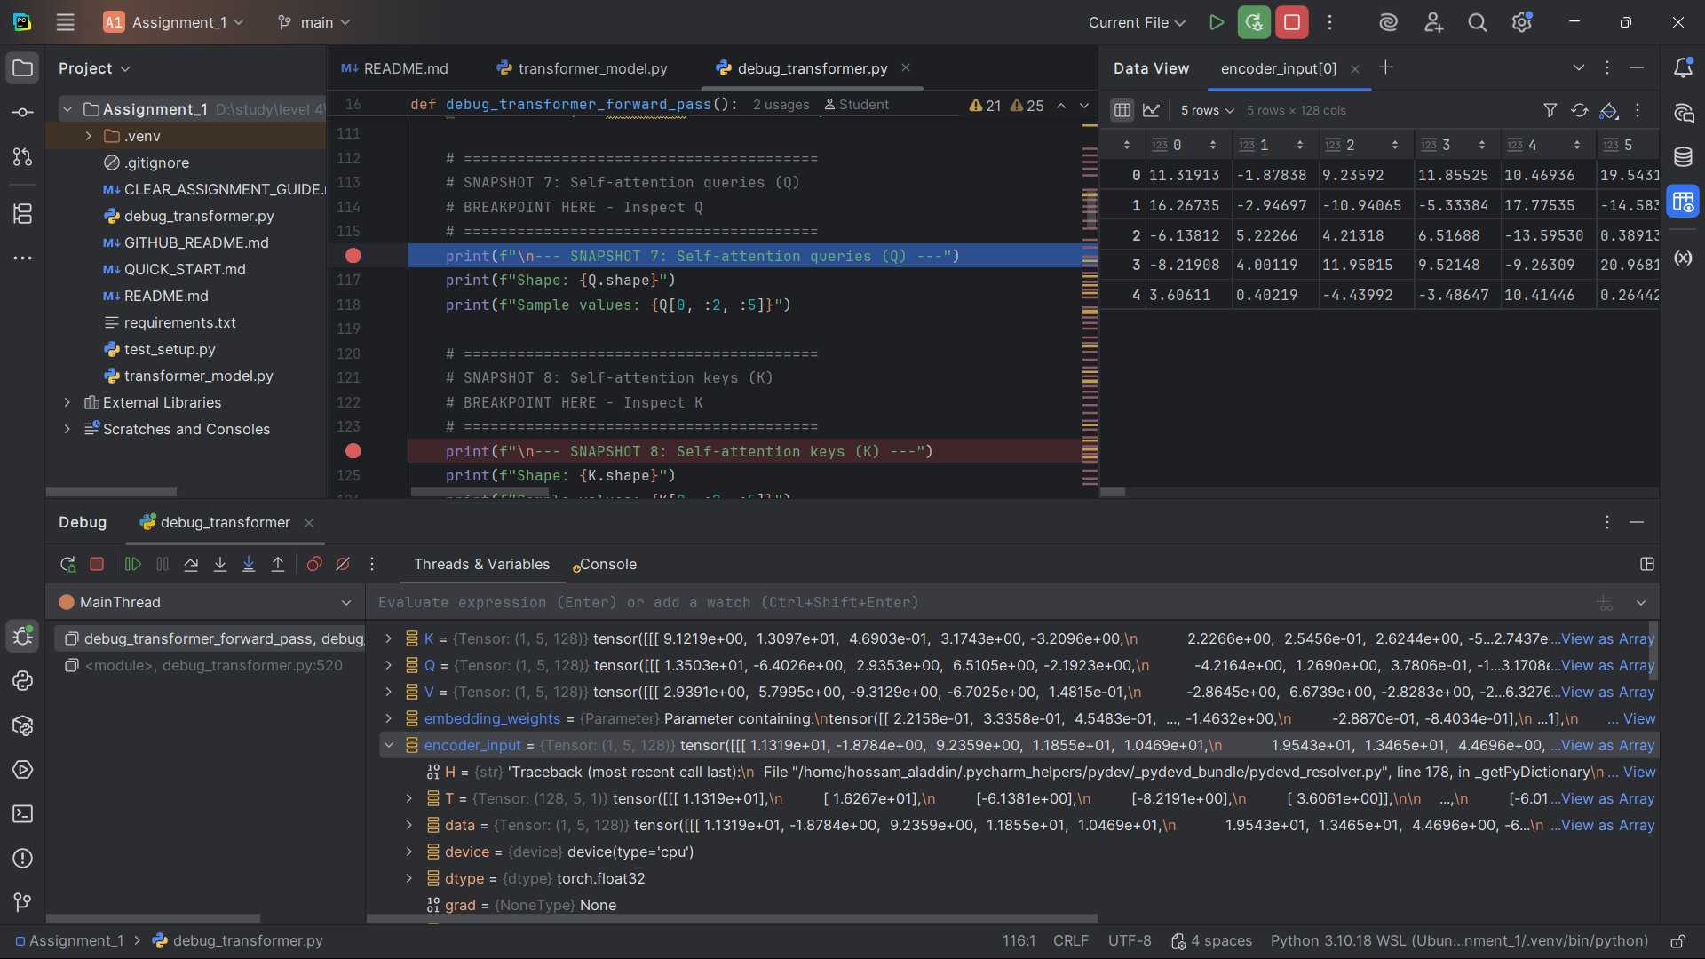]

**Snapshot #7 – Self-attention queries (Q)**

**Expected Shape**: (1, 5, 128)

**Expected Values**: Query vectors for self-attention

**Explanation**: Queries represent "what information am I looking for?" - they determine what the model focuses on.

[Snapshot#7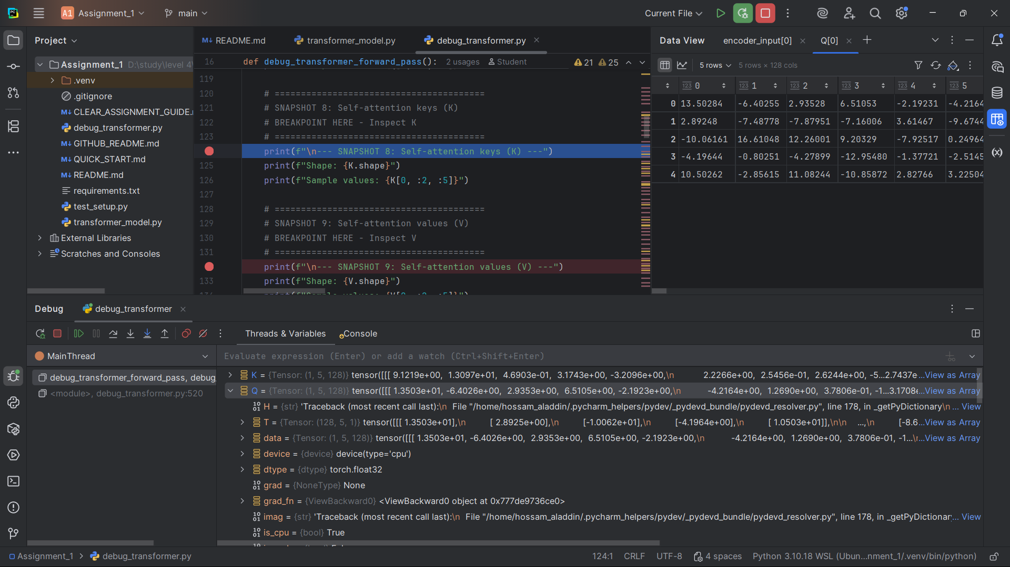]

**Snapshot #8 – Self-attention keys (K)**

**Expected Shape**: (1, 5, 128)

**Expected Values**: Key vectors for self-attention

**Explanation**: Keys represent "what information do I have?" - they determine what information is available to attend to.

[Snapshot#9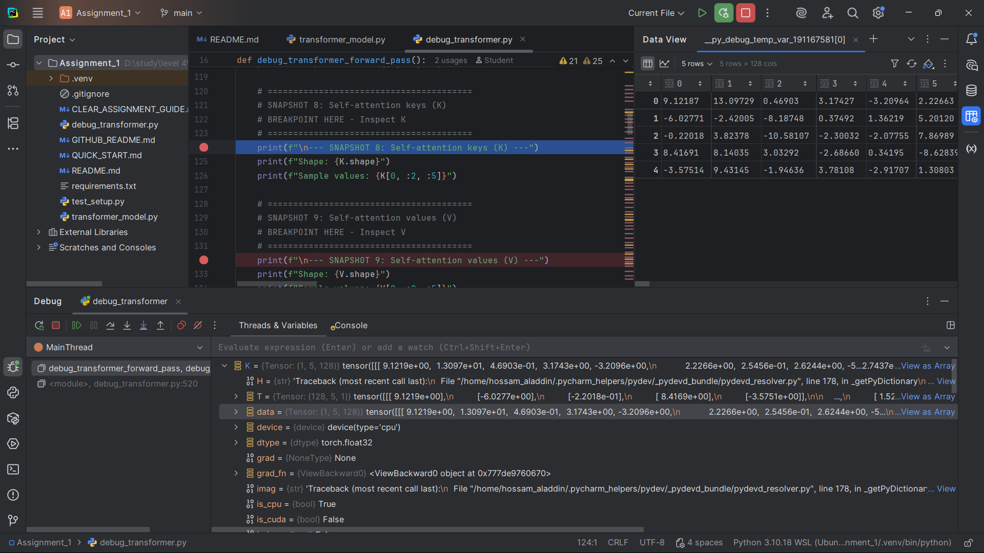]

**Snapshot #9 – Self-attention values (V)**

**Expected Shape**: (1, 5, 128)

**Expected Values**: Value vectors for self-attention

**Explanation**: Values represent "what information do I provide?" - they contain the actual information that gets weighted by attention.

[Snapshot#9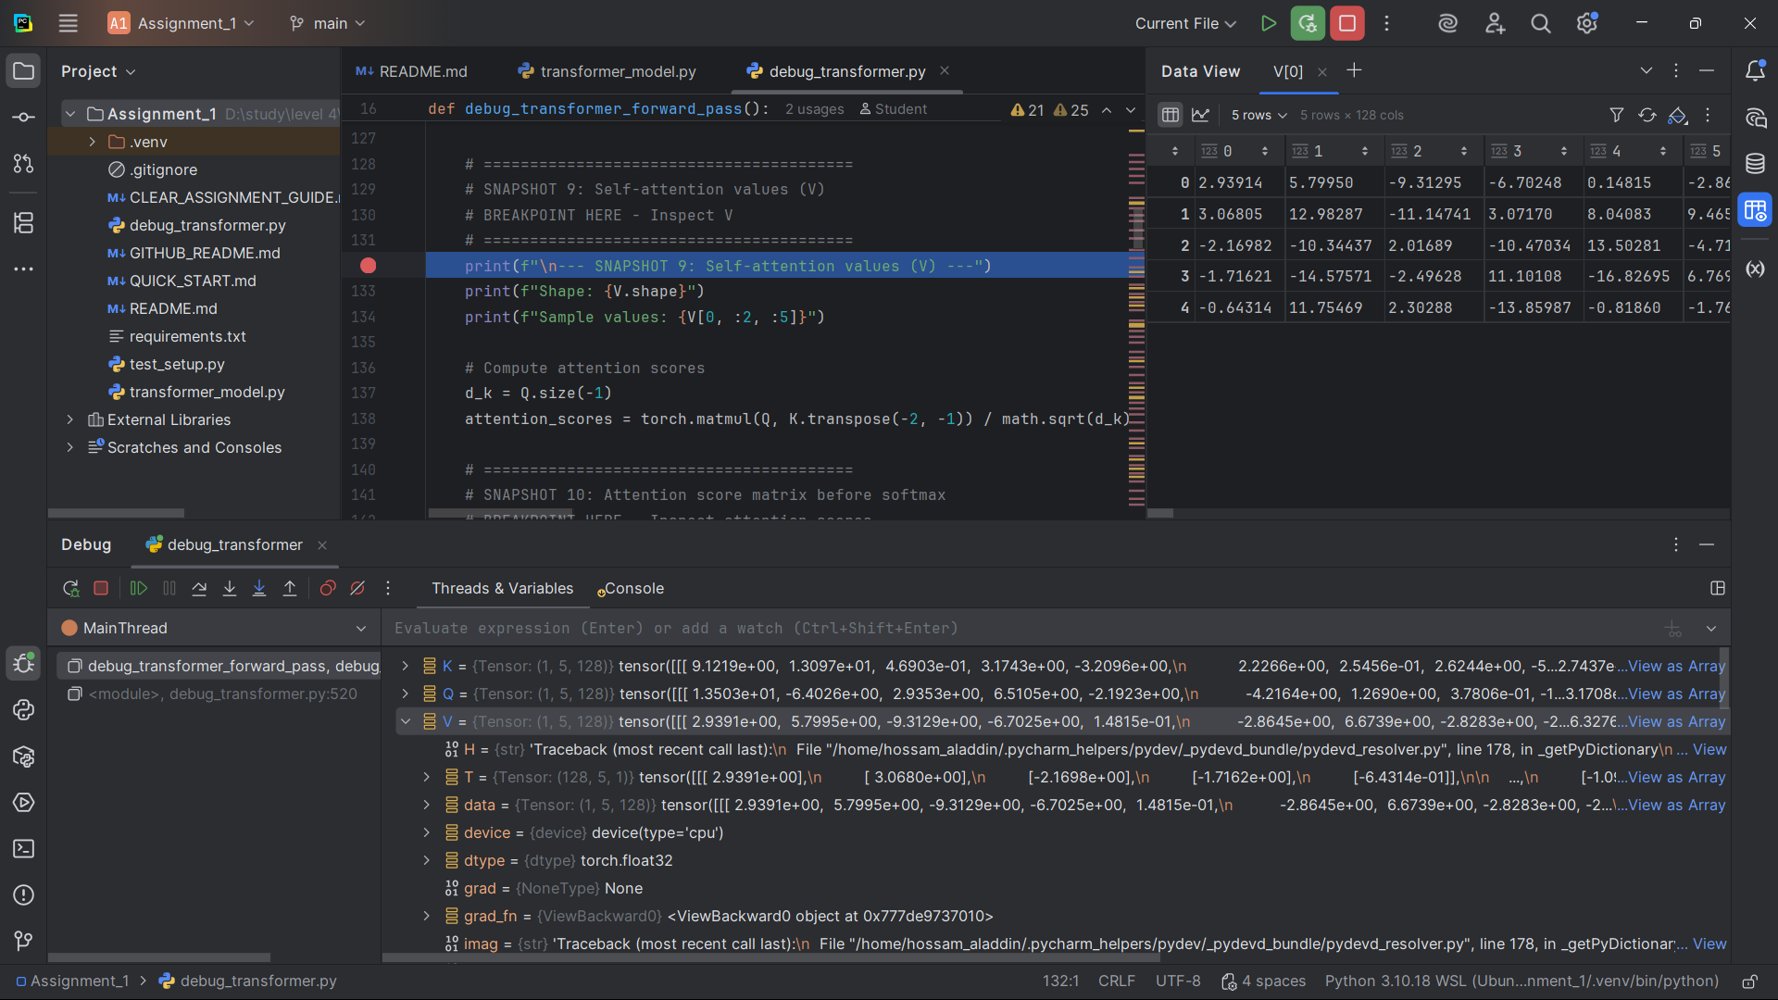]

**Snapshot #10 – Attention score matrix before softmax**

**Expected Shape**: (1, 5, 5)

**Expected Values**: Raw attention scores between all token pairs

**Explanation**: These are the raw similarity scores between queries and keys, before normalization.

[Snapshot#10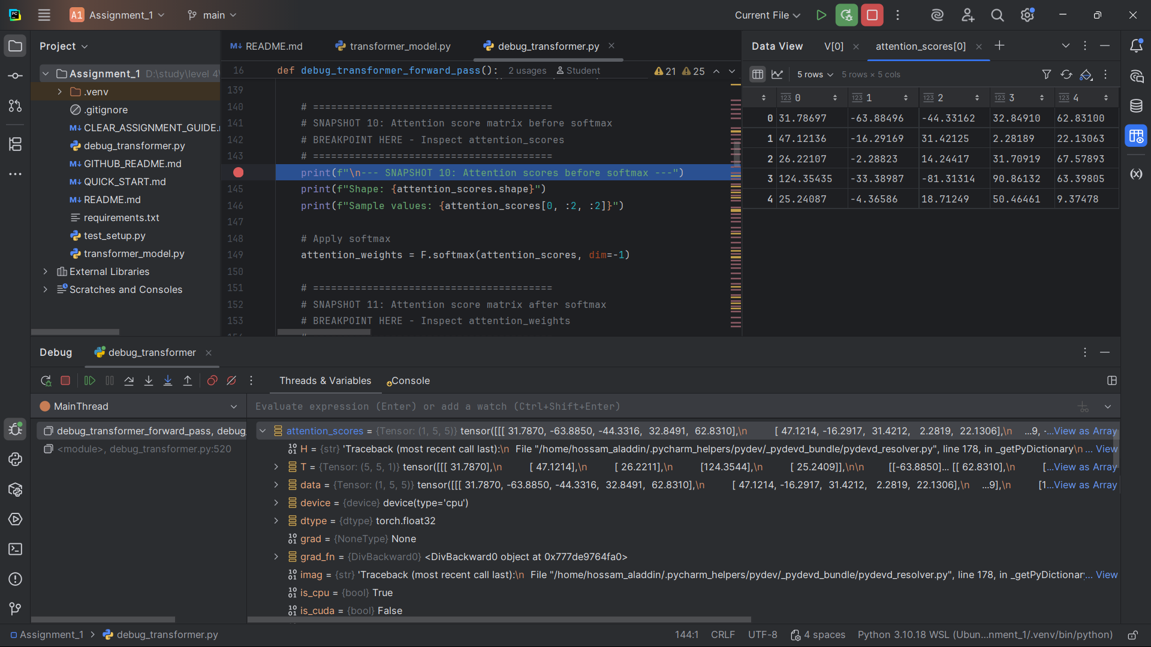]

**Snapshot #11 – Attention score matrix after softmax**

**Expected Shape**: (1, 5, 5)

**Expected Values**: Normalized attention weights (sum to 1)

**Explanation**: Softmax converts raw scores to probabilities, ensuring all attention weights sum to 1.

[Snapshot#11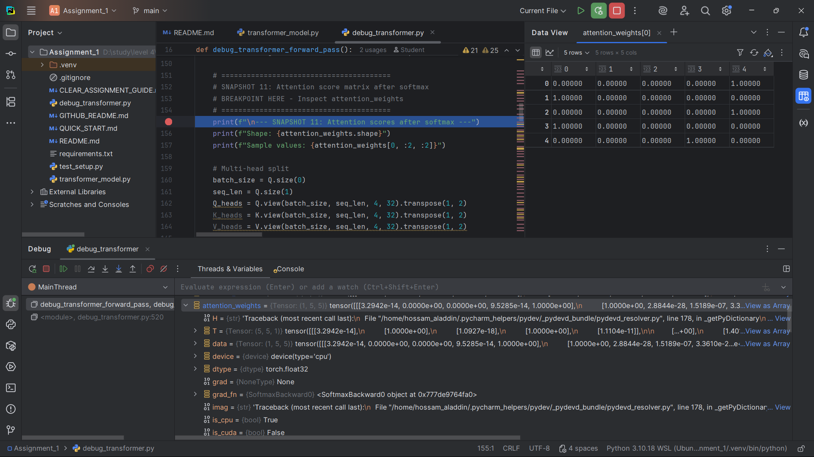]

**Snapshot #12 – Multi-head split (Q/K/V split)**

**Expected Shape**: (1, 4, 5, 32)

**Expected Values**: Q/K/V split into 4 attention heads

**Explanation**: Multi-head attention splits the 128-dimensional vectors into 4 heads of 32 dimensions each.

[Snapshot#12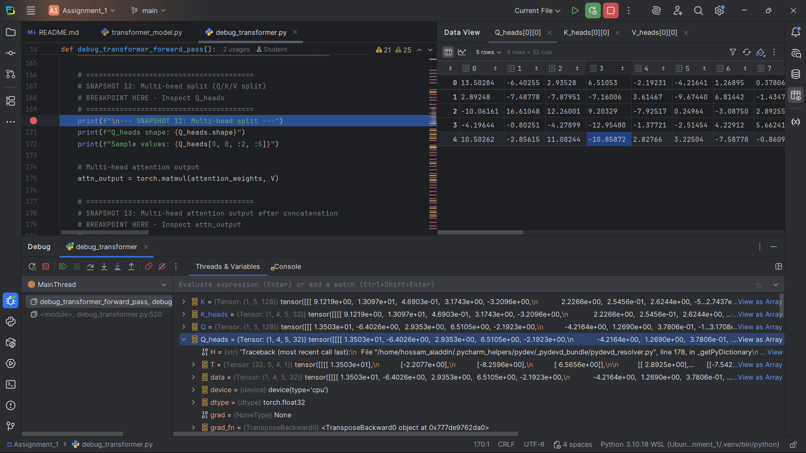]

**Snapshot #13 – Multi-head attention output after concatenation**

**Expected Shape**: (1, 5, 128)

**Expected Values**: Concatenated output from all attention heads

**Explanation**: After processing through multiple heads, the outputs are concatenated back to 128 dimensions.

[Snapshot#13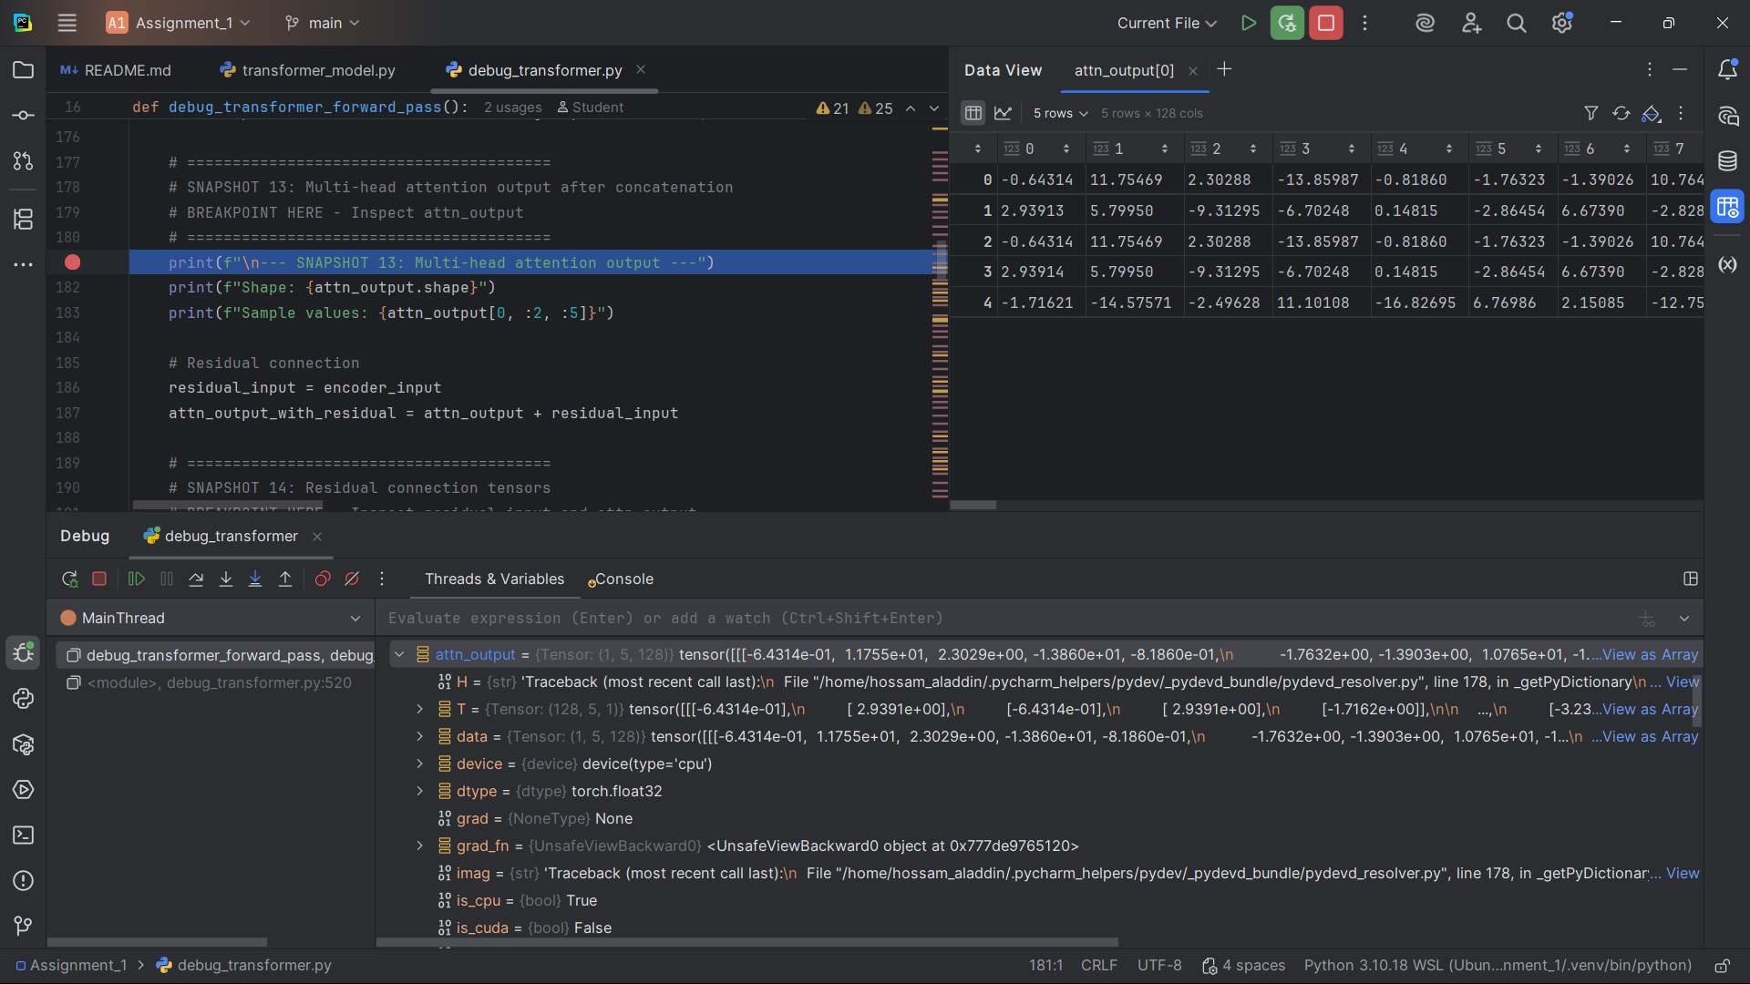]

**Snapshot #14 – Residual connection tensors**

**Expected Shape**: (1, 5, 128) for both

**Expected Values**: Input and output for residual connection

**Explanation**: Residual connections add the input to the output, helping with gradient flow during training.

[Snapshot#14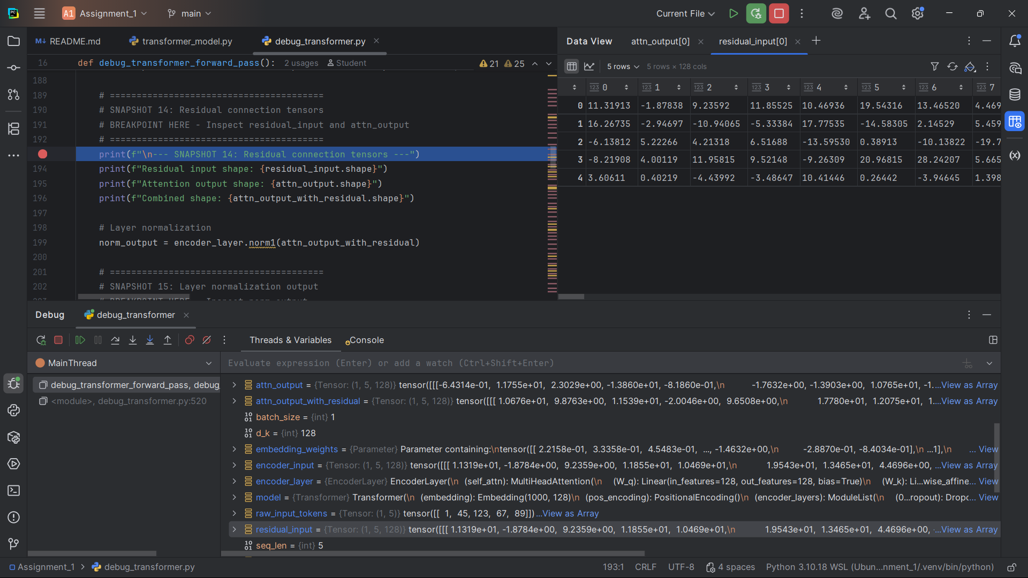]

**Snapshot #15 – Layer normalization output**

**Expected Shape**: (1, 5, 128)

**Expected Values**: Normalized tensor after residual connection

**Explanation**: Layer normalization stabilizes the training by normalizing the activations.

[Snapshot#15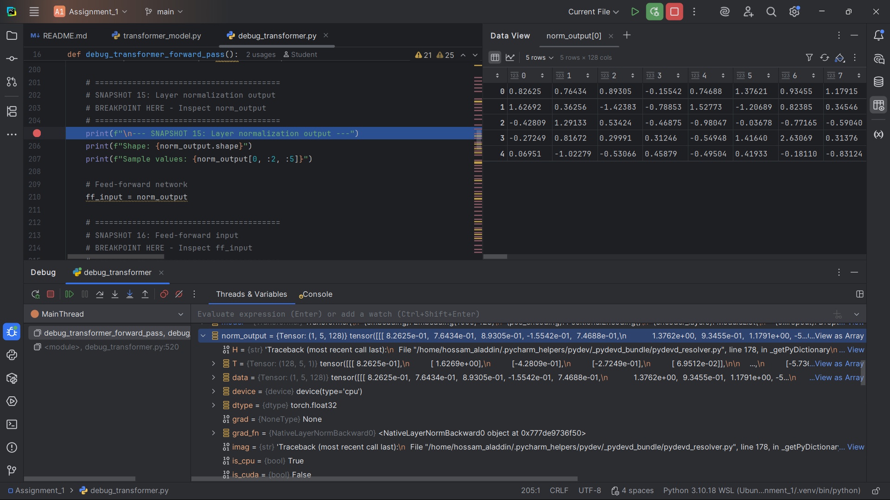]

**Snapshot #16 – Feed-forward input**

**Expected Shape**: (1, 5, 128)

**Expected Values**: Input to the feed-forward network

**Explanation**: This is the input to the position-wise feed-forward network.

[Snapshot#16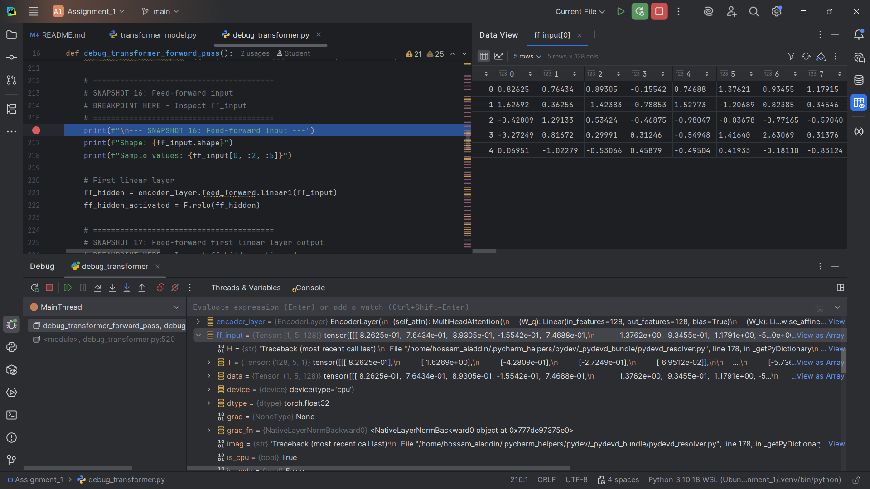]

**Snapshot #17 – Feed-forward first linear layer output**

**Expected Shape**: (1, 5, 512)

**Expected Values**: Output after first linear layer + ReLU

**Explanation**: The first linear layer expands from 128 to 512 dimensions, followed by ReLU activation.

[Snapshot#17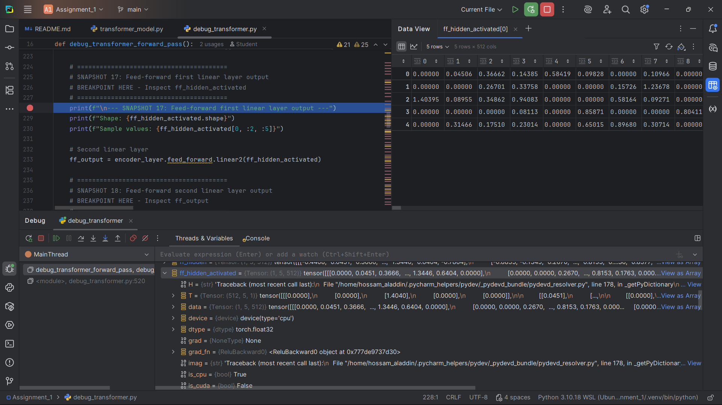]

**Snapshot #18 – Feed-forward second linear layer output**

**Expected Shape**: (1, 5, 128)

**Expected Values**: Output after second linear layer

**Explanation**: The second linear layer compresses back from 512 to 128 dimensions.

[Snapshot#18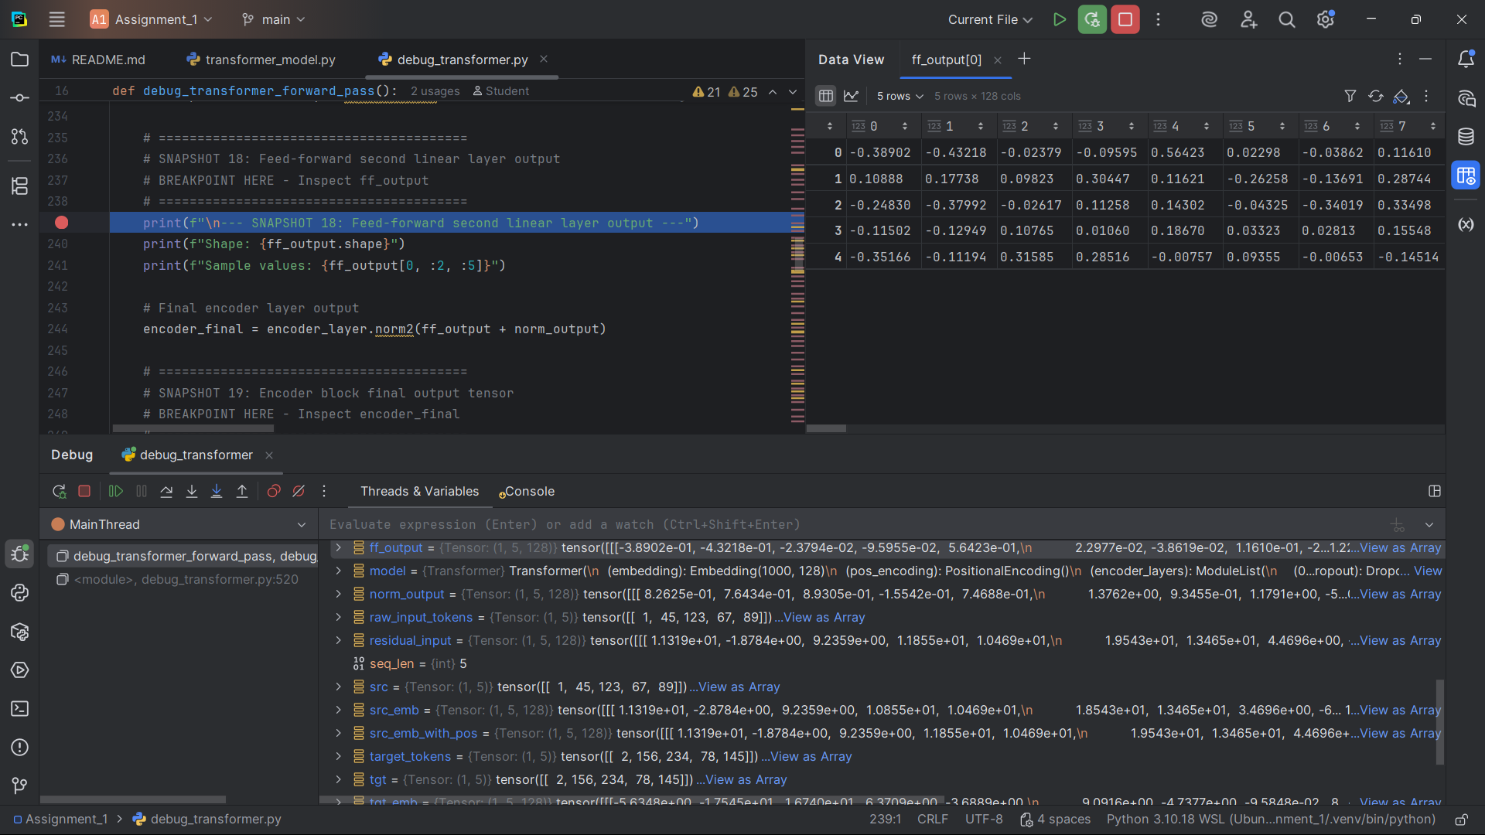]

**Snapshot #19 – Encoder block final output tensor**

**Expected Shape**: (1, 5, 128)

**Expected Values**: Final output of the encoder layer

**Explanation**: This is the final output after all processing in the encoder layer.

[Snapshot#19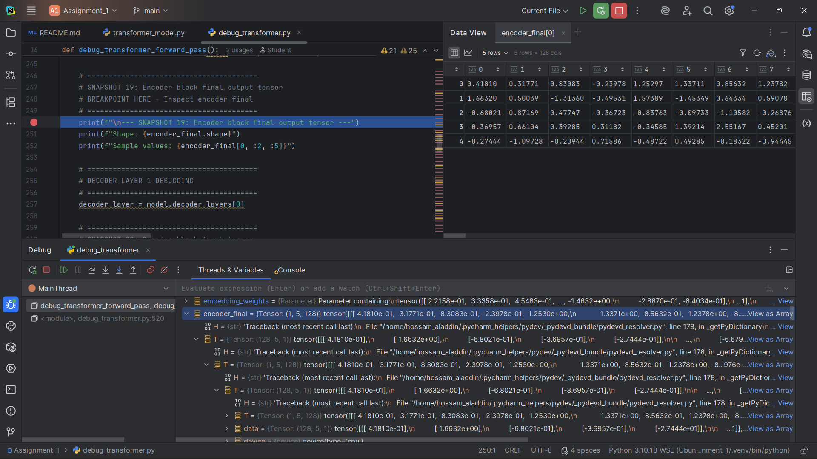]

**Snapshot #20 – Decoder block input tensor**

**Expected Shape**: (1, 5, 128)

**Expected Values**: Input to the first decoder layer

**Explanation**: This is the input tensor for the decoder, which will process the target sequence.

[**Snapshot #20** 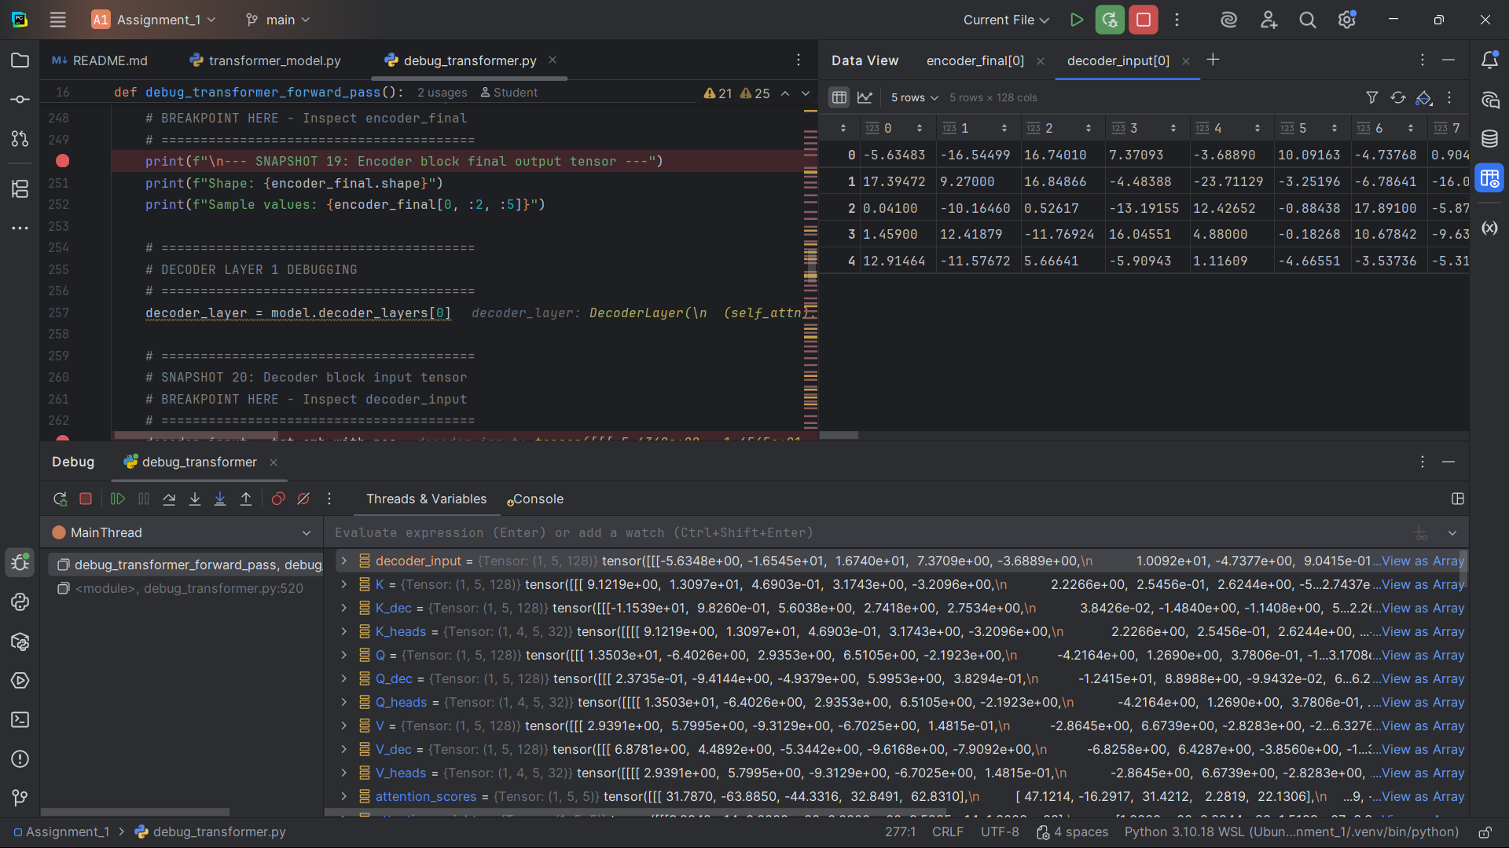]

**Snapshot #21 – Masked self-attention queries (Q)**

**Expected Shape**: (1, 5, 128)

**Expected Values**: Query vectors for masked self-attention

**Explanation**: Queries for the decoder's self-attention mechanism.

[Snapshot#21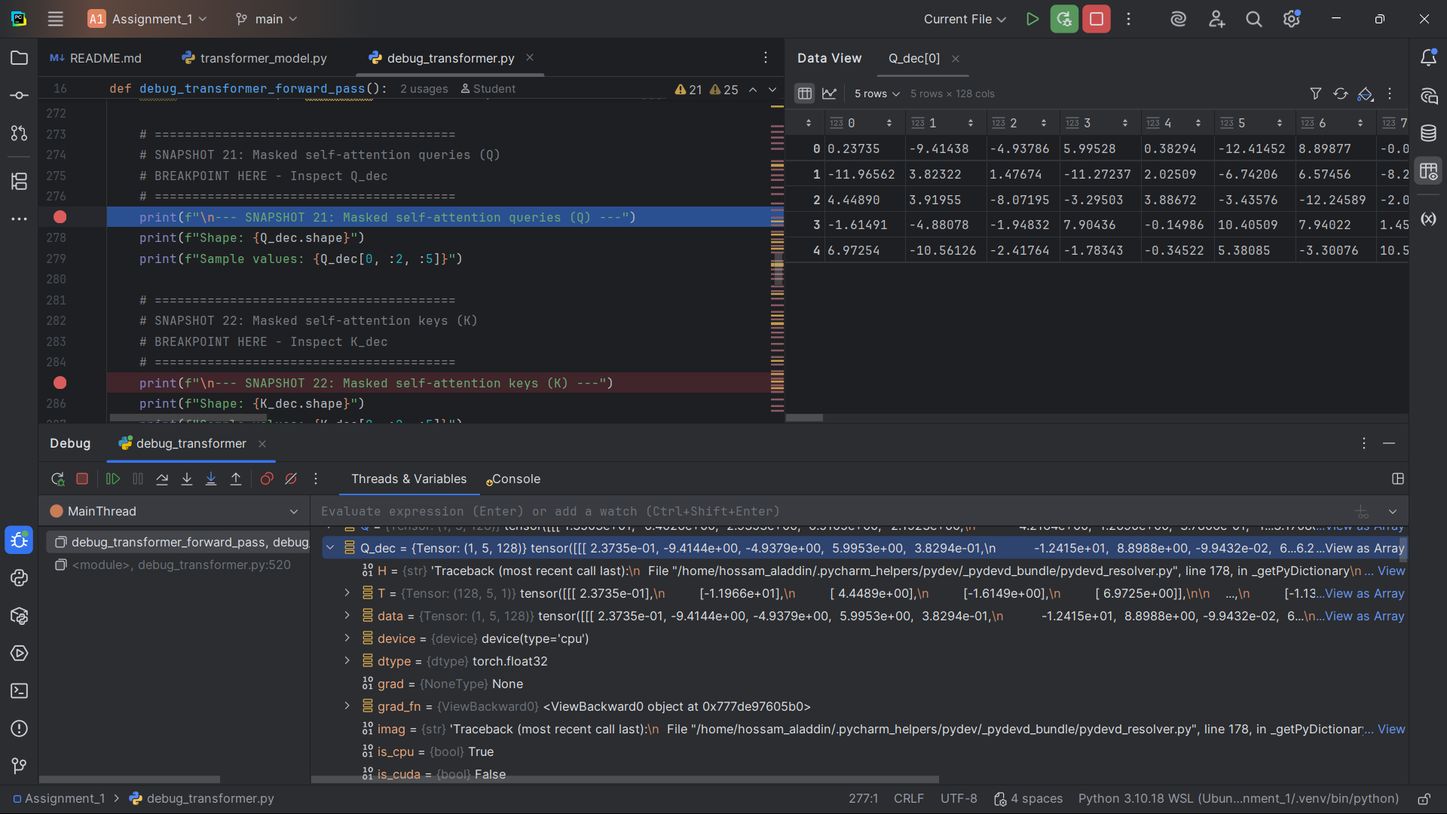]

**Snapshot #22 – Masked self-attention keys (K)**

**Expected Shape**: (1, 5, 128)

**Expected Values**: Key vectors for masked self-attention

**Explanation**: Keys for the decoder's self-attention mechanism.

[Snapshot#22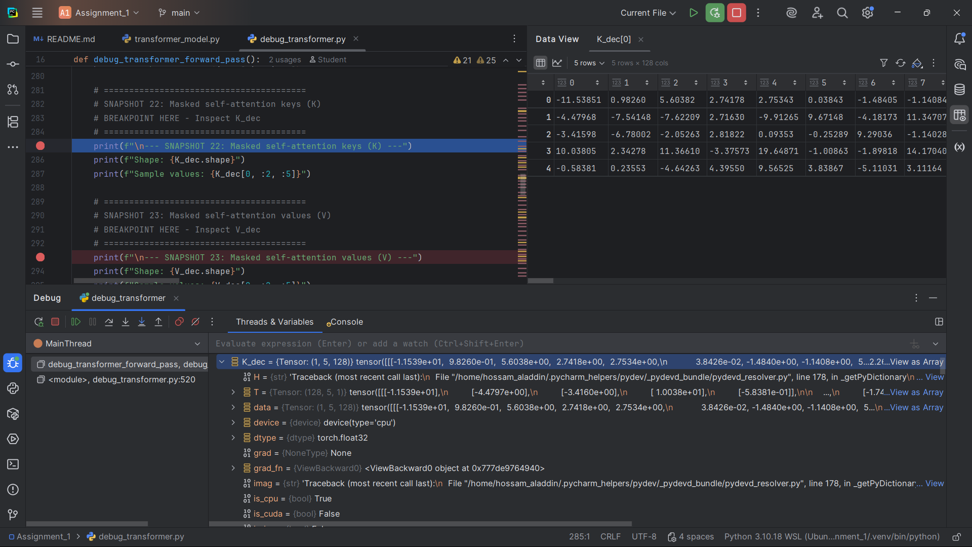]

**Snapshot #23 – Masked self-attention values (V)**

**Expected Shape**: (1, 5, 128)

**Expected Values**: Value vectors for masked self-attention

**Explanation**: Values for the decoder's self-attention mechanism.

[Snapshot#23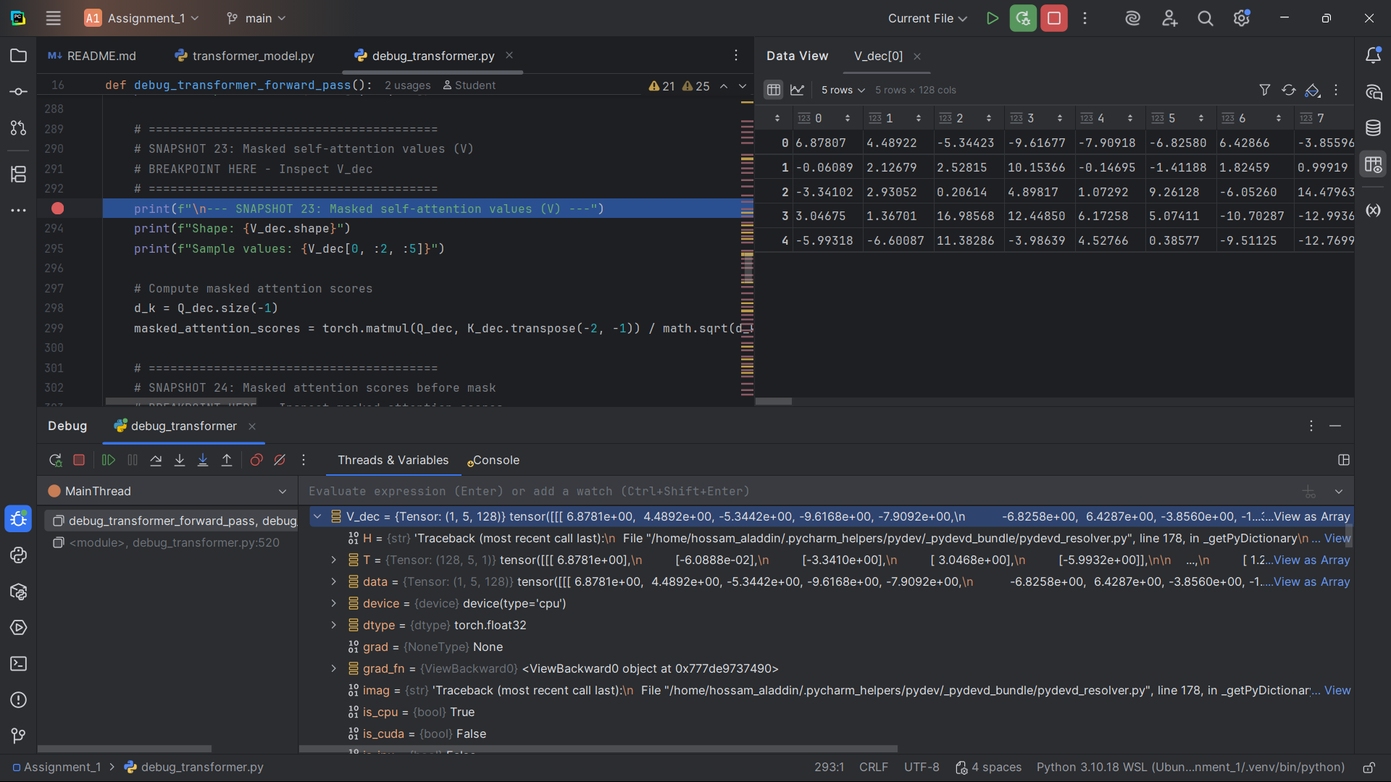]

**Snapshot #24 – Masked attention scores before mask**

**Expected Shape**: (1, 5, 5)

**Expected Values**: Raw attention scores before masking

**Explanation**: Raw attention scores before applying the causal mask.

[Snapshot #24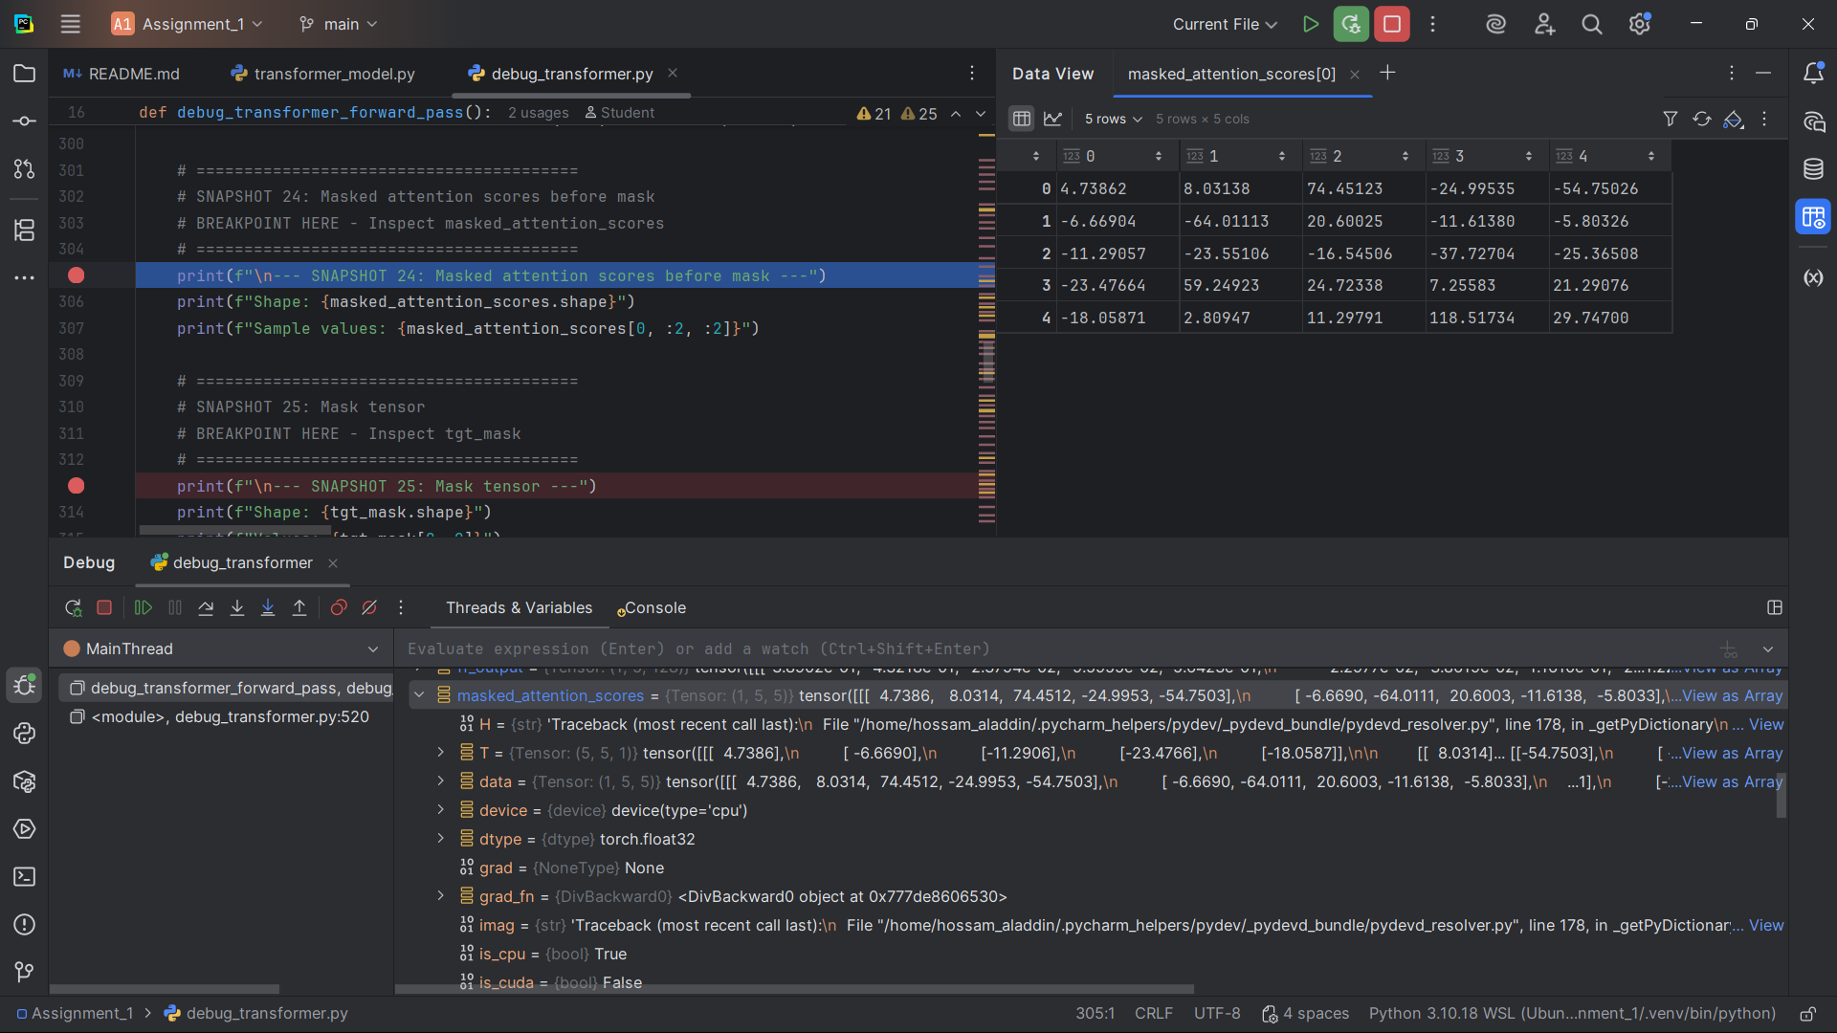]

**Snapshot #25 – Mask tensor**

**Expected Shape**: (1, 1, 5, 5)

**Expected Values**: Causal mask (lower triangular matrix)

**Explanation**: The causal mask prevents the model from attending to future tokens during training.

[Snapshot#25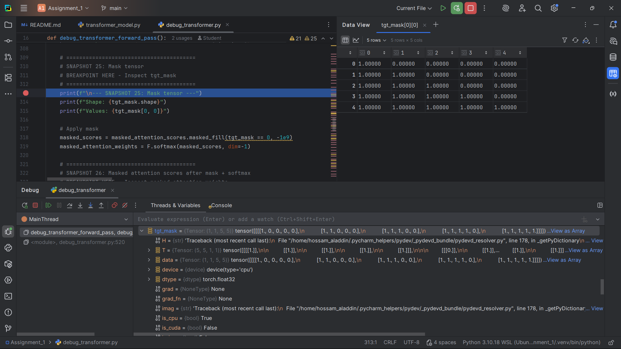]

**Snapshot #26 – Masked attention scores after mask + softmax**

**Expected Shape**: (1, 1, 5, 5)

**Expected Values**: Masked and normalized attention weights

**Explanation**: After applying the mask and softmax, we get valid attention weights.

[Snapshot #26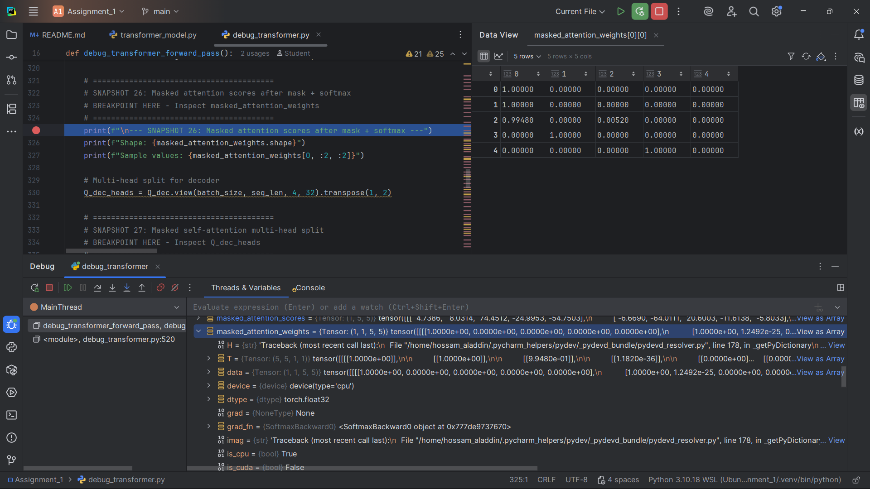]

**Snapshot #27 – Masked self-attention multi-head split**

**Expected Shape**: (1, 4, 5, 32)

**Expected Values**: Q/K/V split into multiple attention heads

**Explanation**: Multi-head attention splits the vectors into 4 heads of 32 dimensions each.

[Snapshot #27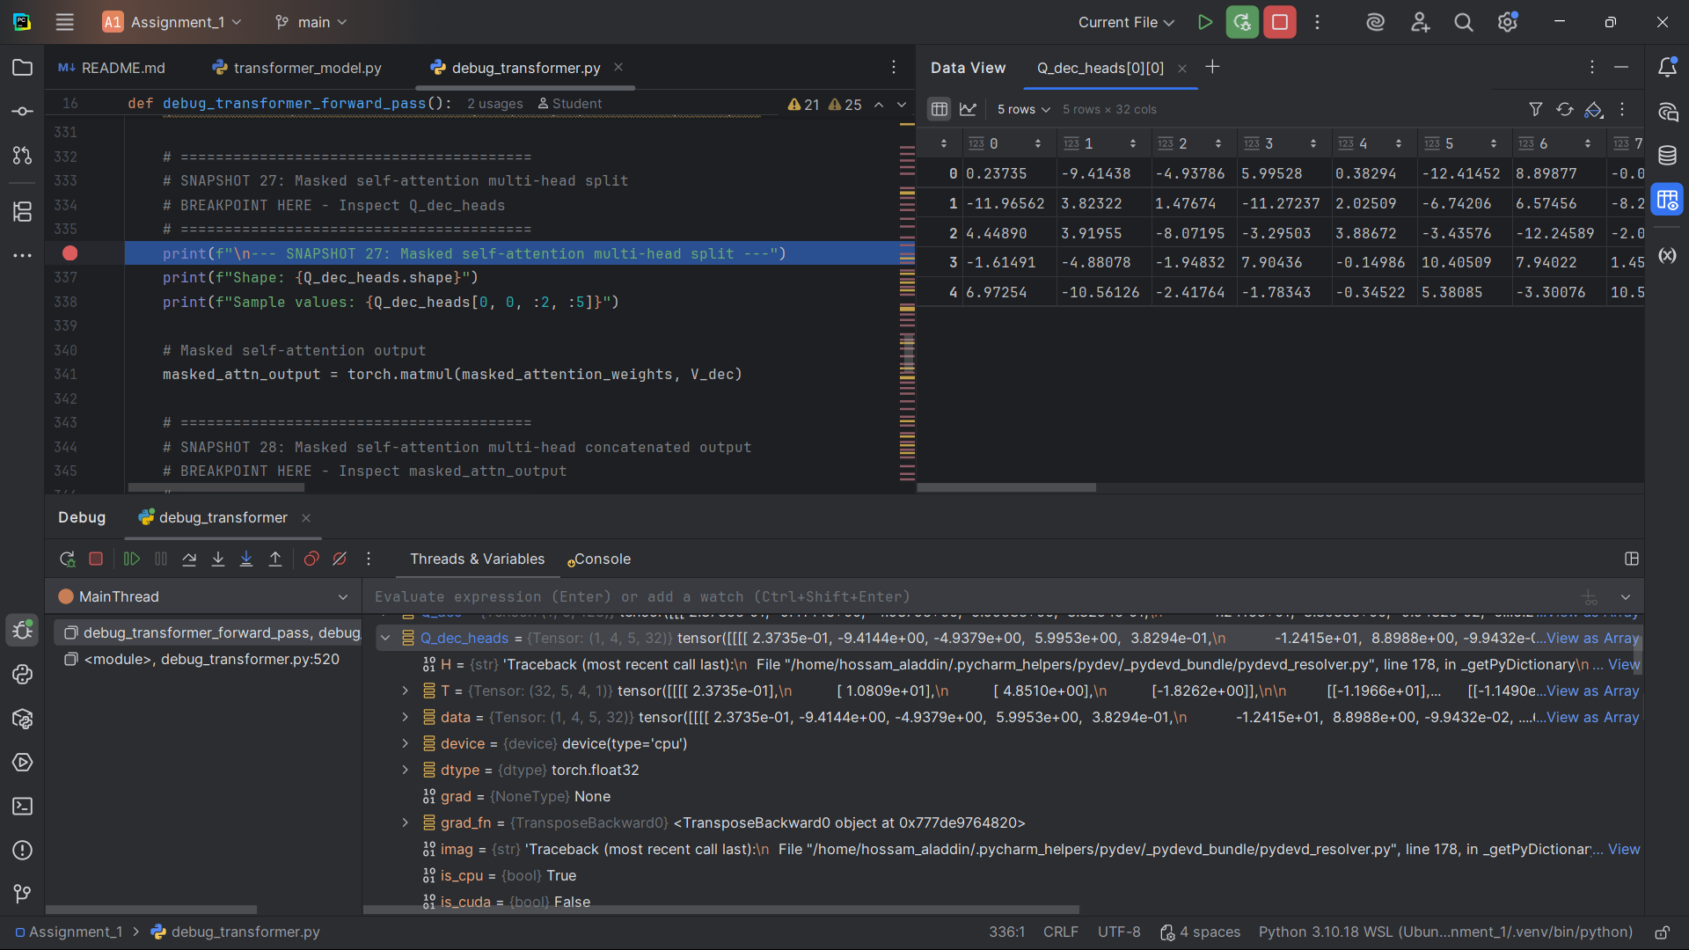]

**Snapshot #28 – Masked self-attention multi-head concatenated output**

**Expected Shape**: (1, 1, 5, 128)

**Expected Values**: Concatenated output from all attention heads

**Explanation**: After processing through multiple heads, the outputs are concatenated.

[Snapshot #28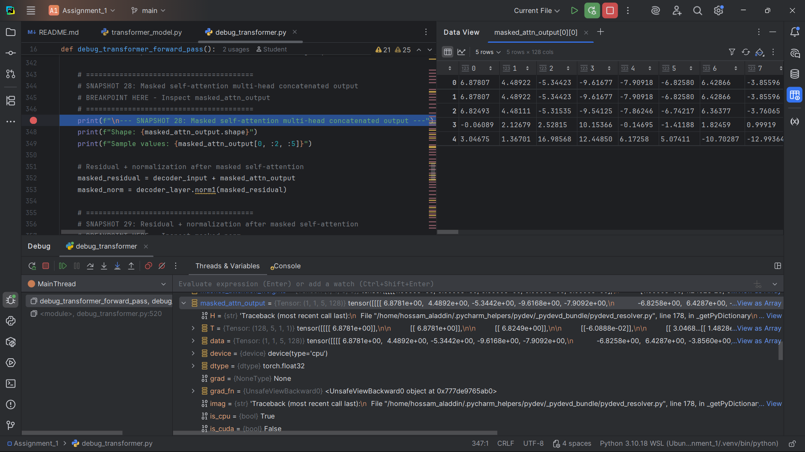]

**Snapshot #29 – Residual + normalization after masked self-attention**

**Expected Shape**: (1, 1, 5, 128)

**Expected Values**: Output after residual connection and normalization

**Explanation**: After the masked self-attention, we apply residual connection and layer normalization.

[Snapshot #29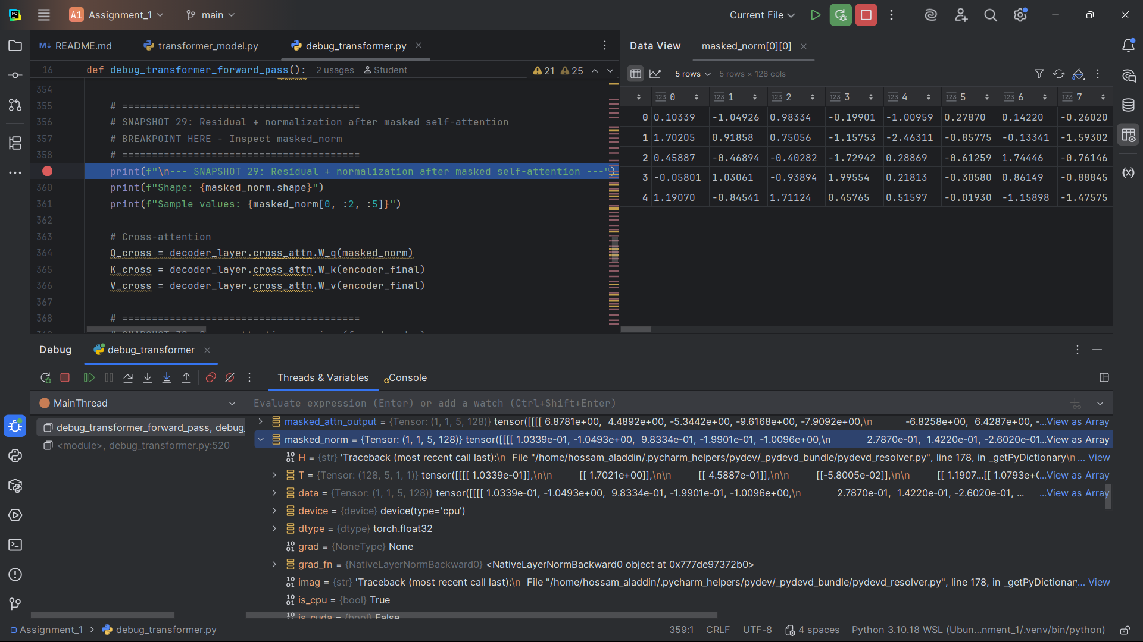]

**Snapshot #30 – Cross-attention queries (from decoder)**

**Expected Shape**: (1, 1, 5, 128)

**Expected Values**: Query vectors for cross-attention

**Explanation**: Queries from the decoder for attending to encoder outputs.

[Snapshot #30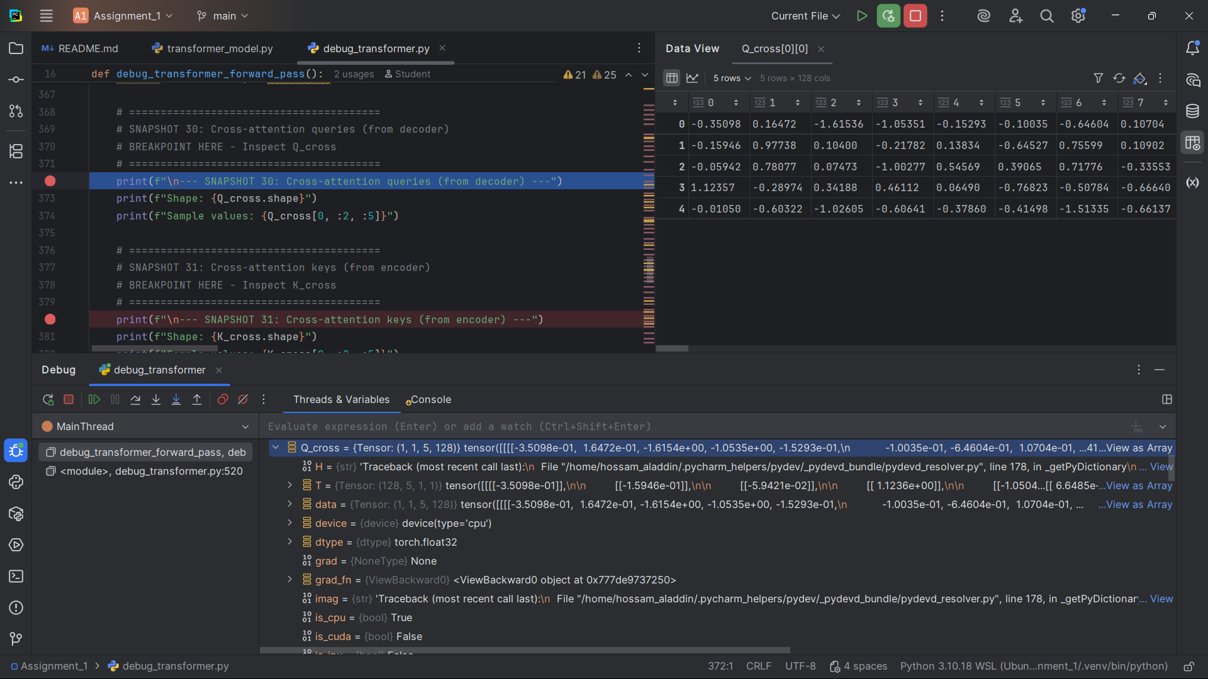]

**Snapshot #31 – Cross-attention keys (from encoder)**

**Expected Shape**: (1, 5, 128)

**Expected Values**: Key vectors from encoder output

**Explanation**: Keys from the encoder output for cross-attention.

[Snapshot #31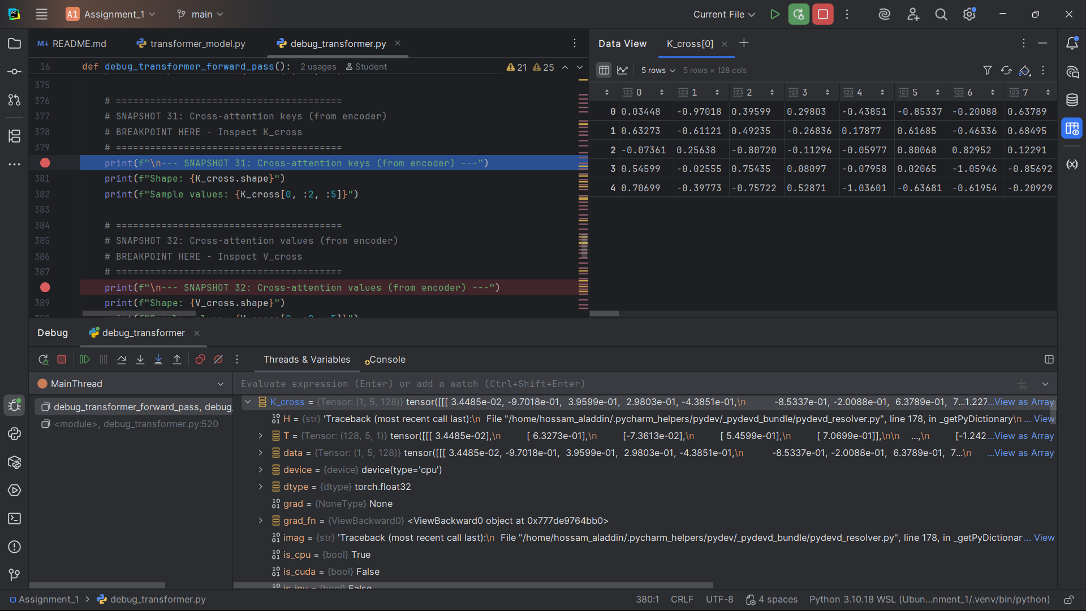]

**Snapshot #32 – Cross-attention values (from encoder)**

**Expected Shape**: (1, 5, 128)

**Expected Values**: Value vectors from encoder output

**Explanation**: Values from the encoder output for cross-attention.

[Snapshot #32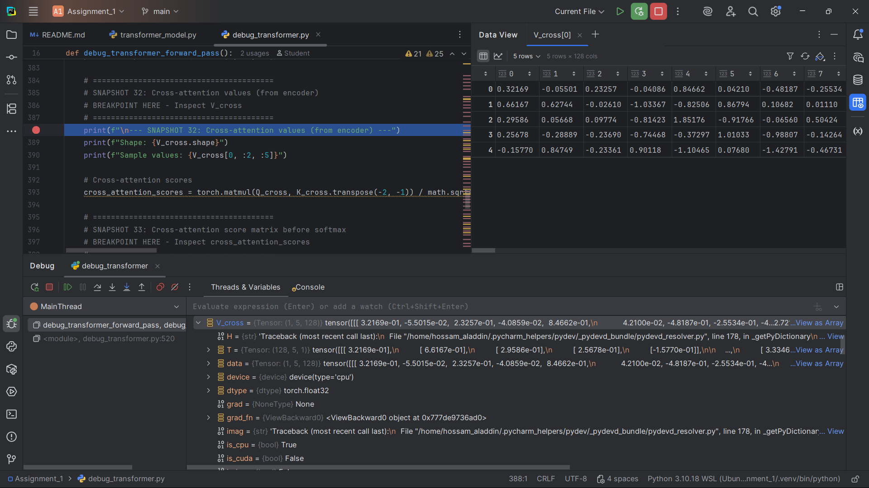]

**Snapshot #33 – Cross-attention score matrix before softmax**

**Expected Shape**: (1, 1, 5, 5)

**Expected Values**: Raw cross-attention scores

**Explanation**: Raw similarity scores between decoder queries and encoder keys.

[Snapshot #33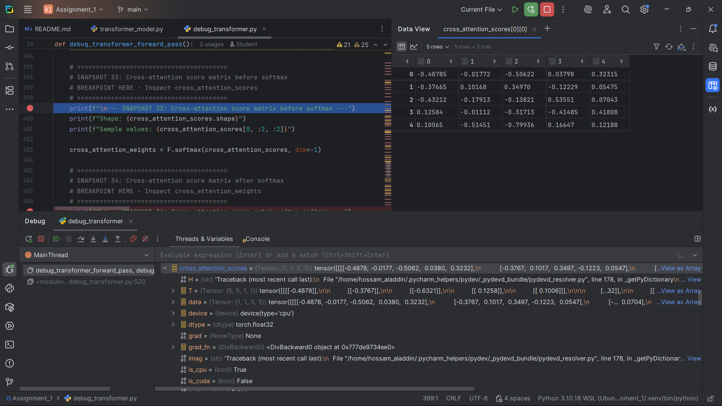]

**Snapshot #34 – Cross-attention score matrix after softmax**

**Expected Shape**: (1, 1, 5, 5)

**Expected Values**: Normalized cross-attention weights

**Explanation**: Softmax converts raw scores to probabilities for cross-attention.

[Snapshot #34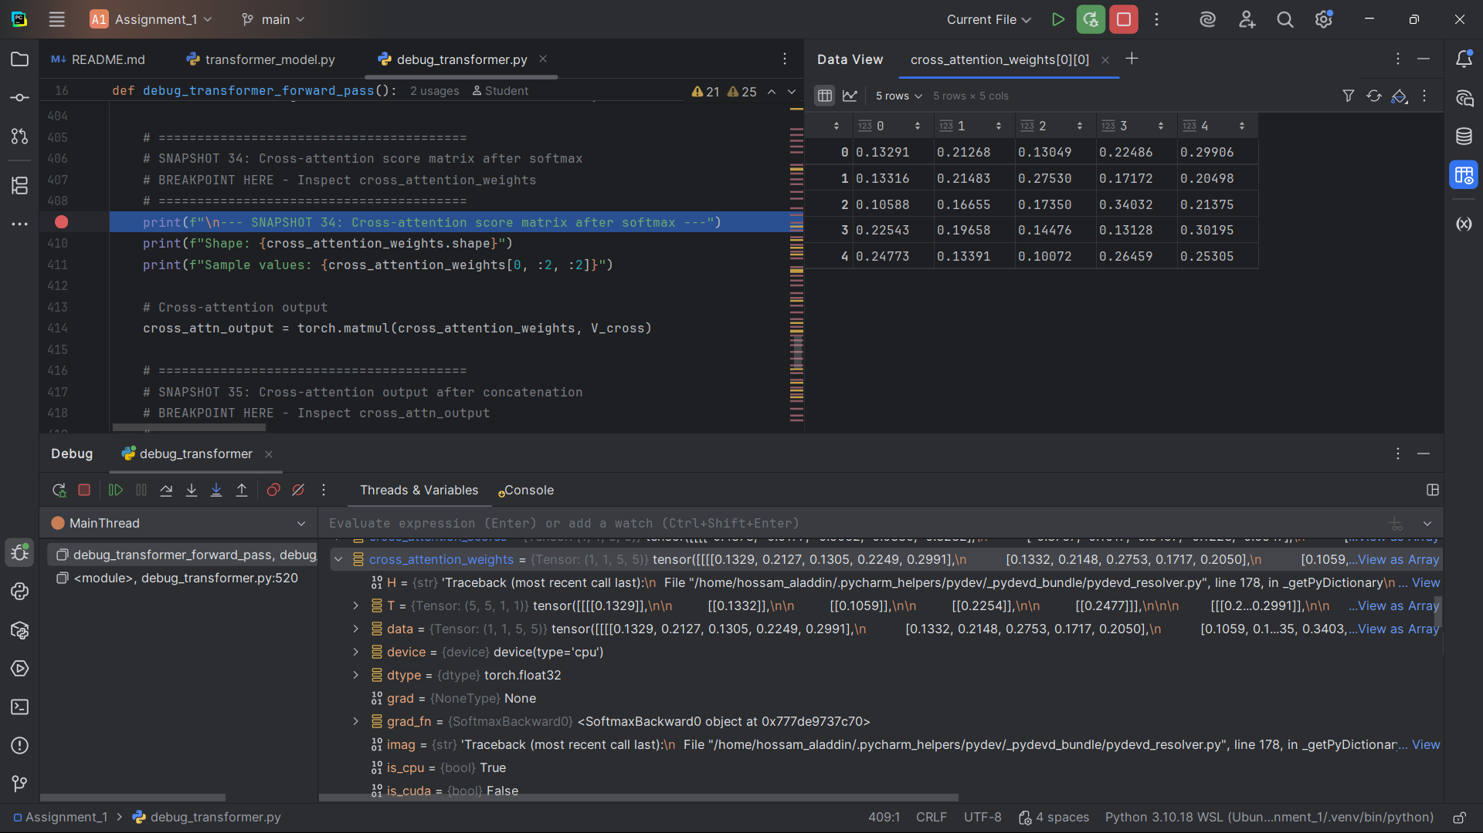]

**Snapshot #35 – Cross-attention output after concatenation**

**Expected Shape**: (1, 1, 5, 128)

**Expected Values**: Cross-attention output

**Explanation**: The weighted combination of encoder values based on cross-attention weights.

[Snapshot #35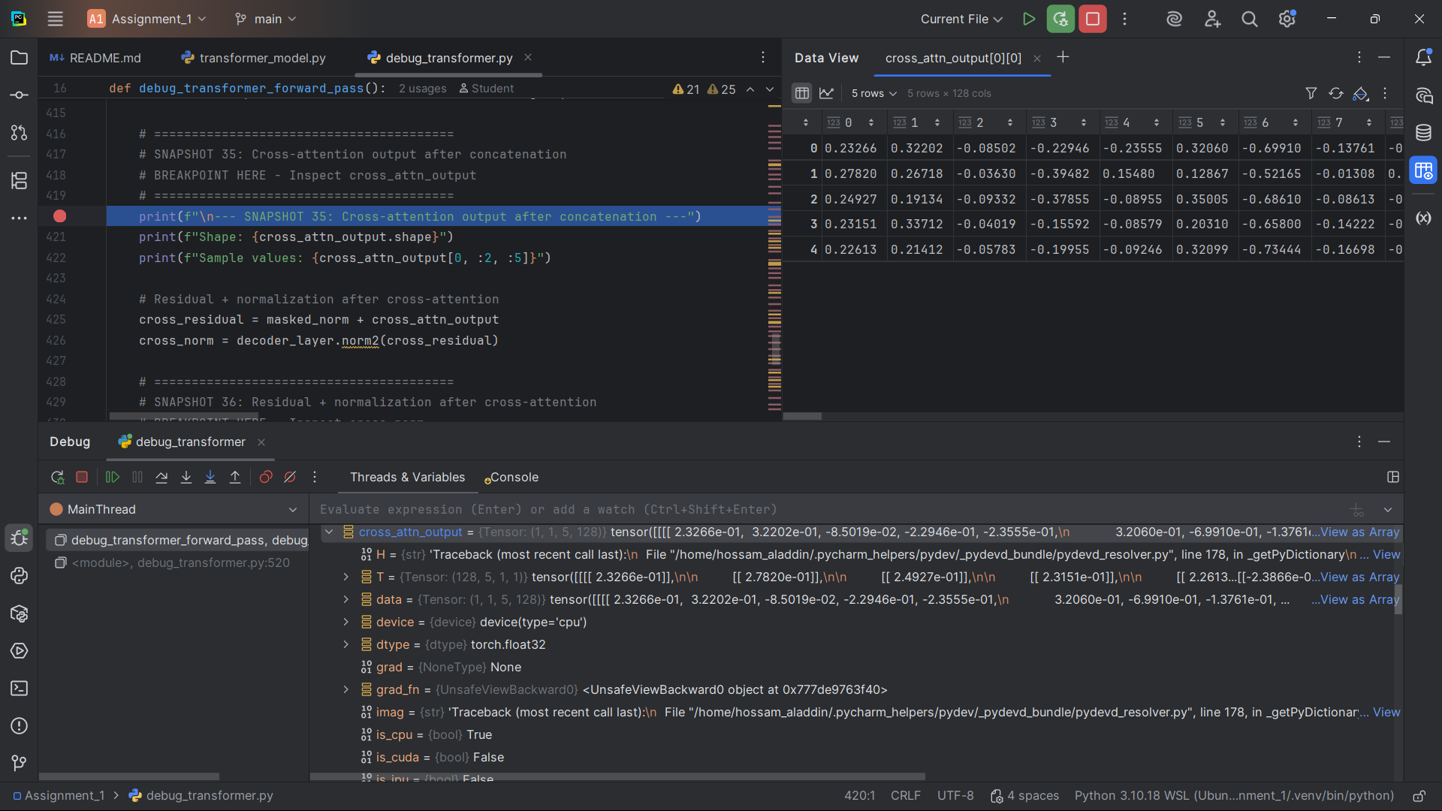]

**Snapshot #36 – Residual + normalization after cross-attention**

**Expected Shape**: (1, 1, 5, 128)

**Expected Values**: Output after residual connection and normalization

**Explanation**: After cross-attention, we apply residual connection and layer normalization.

[Snapshot #36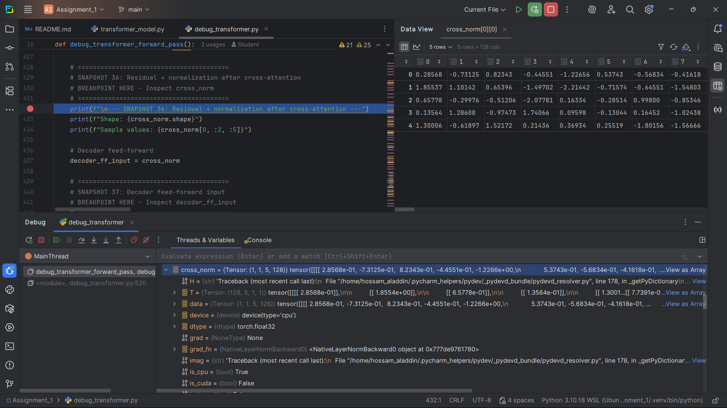]

**Snapshot #37 – Decoder feed-forward input**

**Expected Shape**: (1, 1, 5, 128)

**Expected Values**: Input to decoder feed-forward network

**Explanation**: This is the input to the decoder's feed-forward network.

[Snapshot #37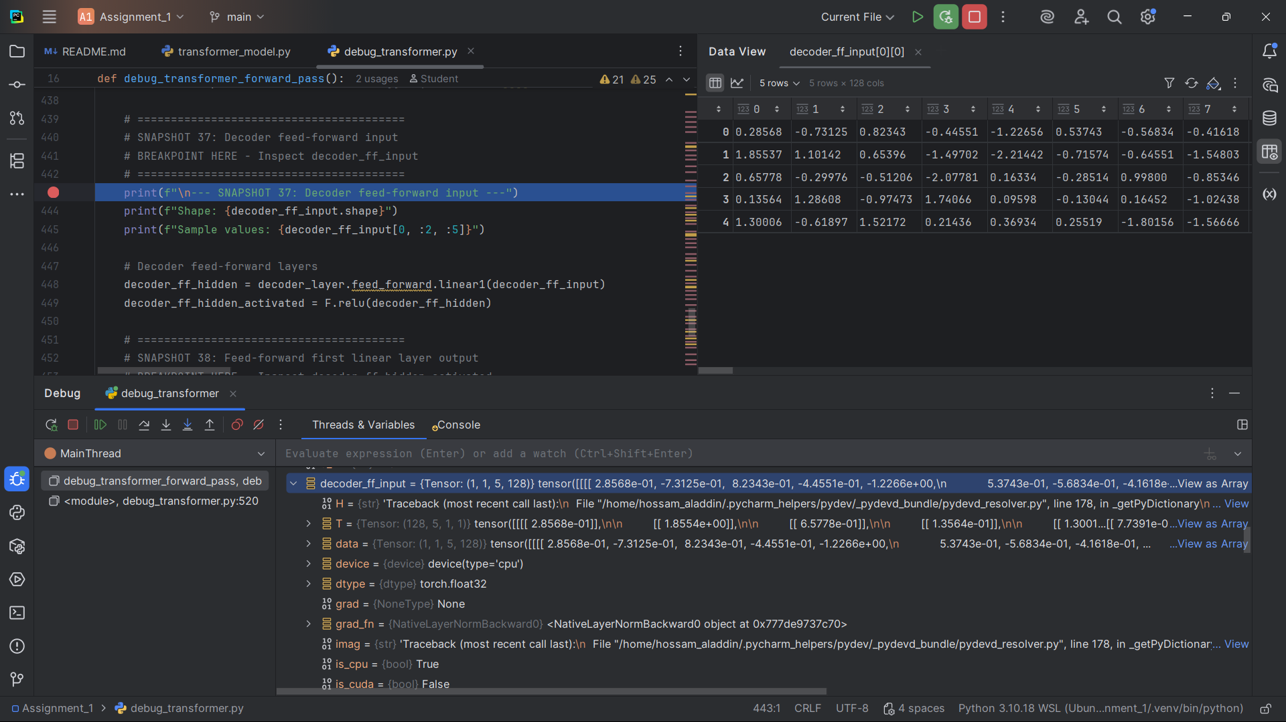]

**Snapshot #38 – Feed-forward first linear layer output**

**Expected Shape**: (1, 1, 5, 512)

**Expected Values**: Output after first linear layer + ReLU

**Explanation**: The first linear layer expands from 128 to 512 dimensions, followed by ReLU activation.

[Snapshot #38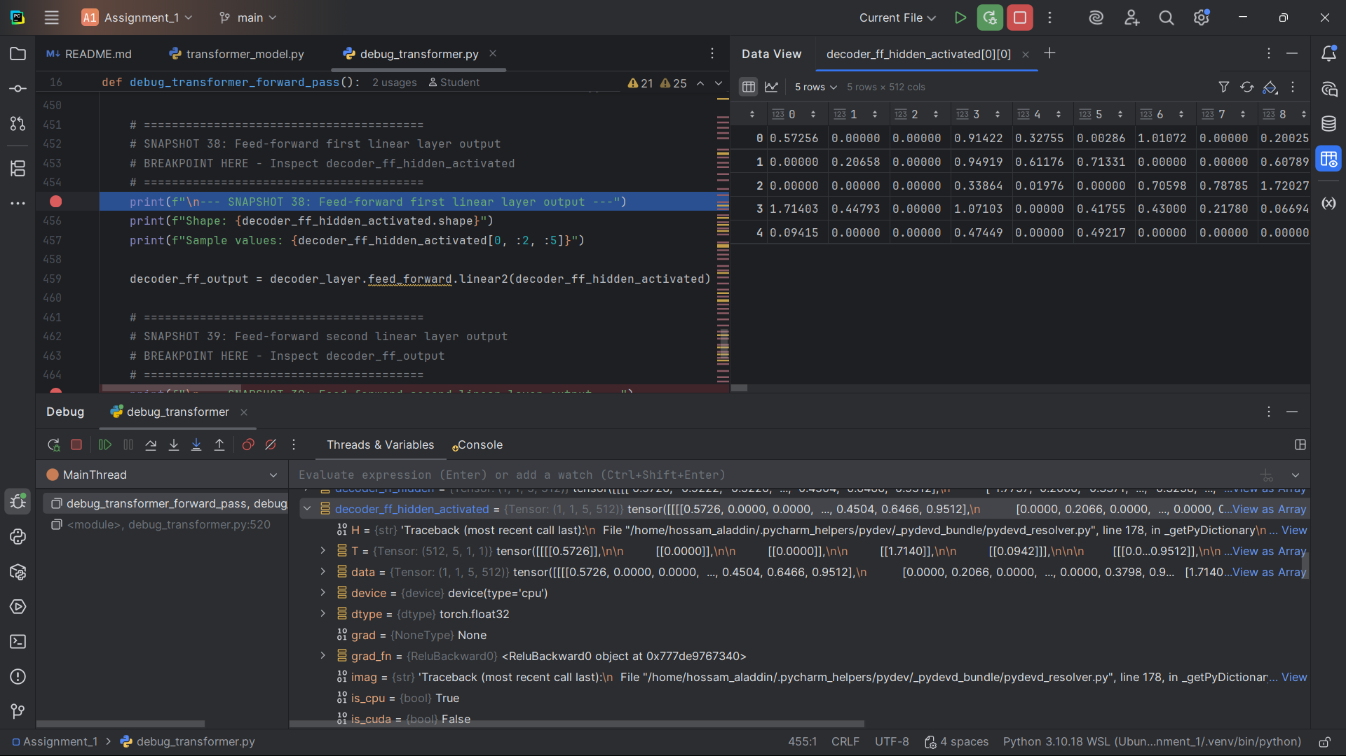]

**Snapshot #39 – Feed-forward second linear layer output**

**Expected Shape**: (1, 1, 5, 128)

**Expected Values**: Output after second linear layer

**Explanation**: The second linear layer compresses back from 512 to 128 dimensions.

[Snapshot #39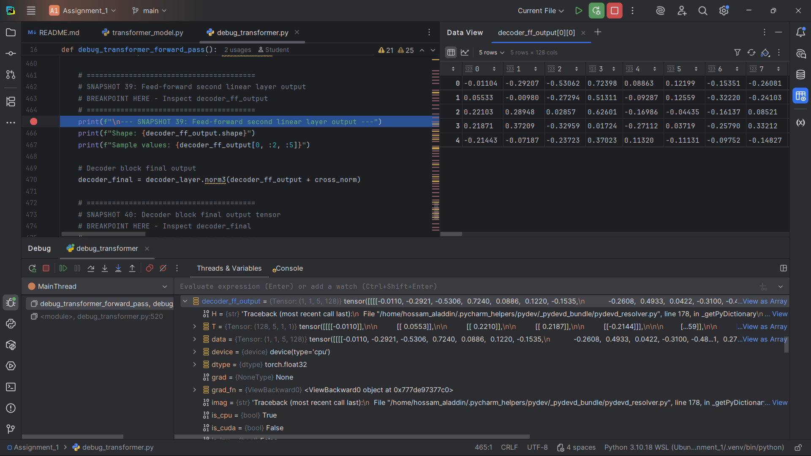]

**Snapshot #40 – Decoder block final output tensor**

**Expected Shape**: (1, 1, 5, 128)

**Expected Values**: Final output of the decoder layer

**Explanation**: This is the final output after all processing in the decoder layer.

[Snapshot #40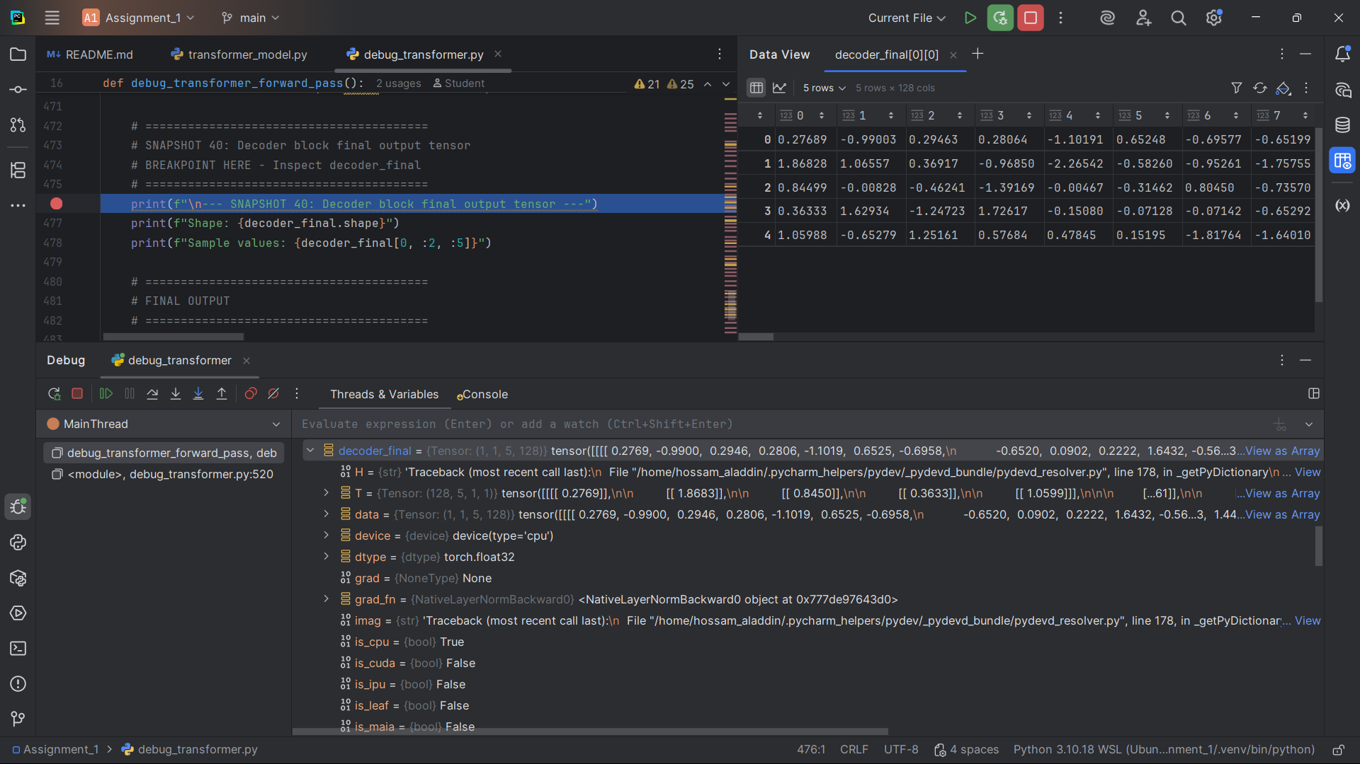]

**Snapshot #41 – Decoder final sequence output (before projection)**

**Expected Shape**: (1, 1, 5, 128)

**Expected Values**: Final decoder output before projection

**Explanation**: This is the final decoder output before the linear projection to vocabulary logits.

[Snapshot #41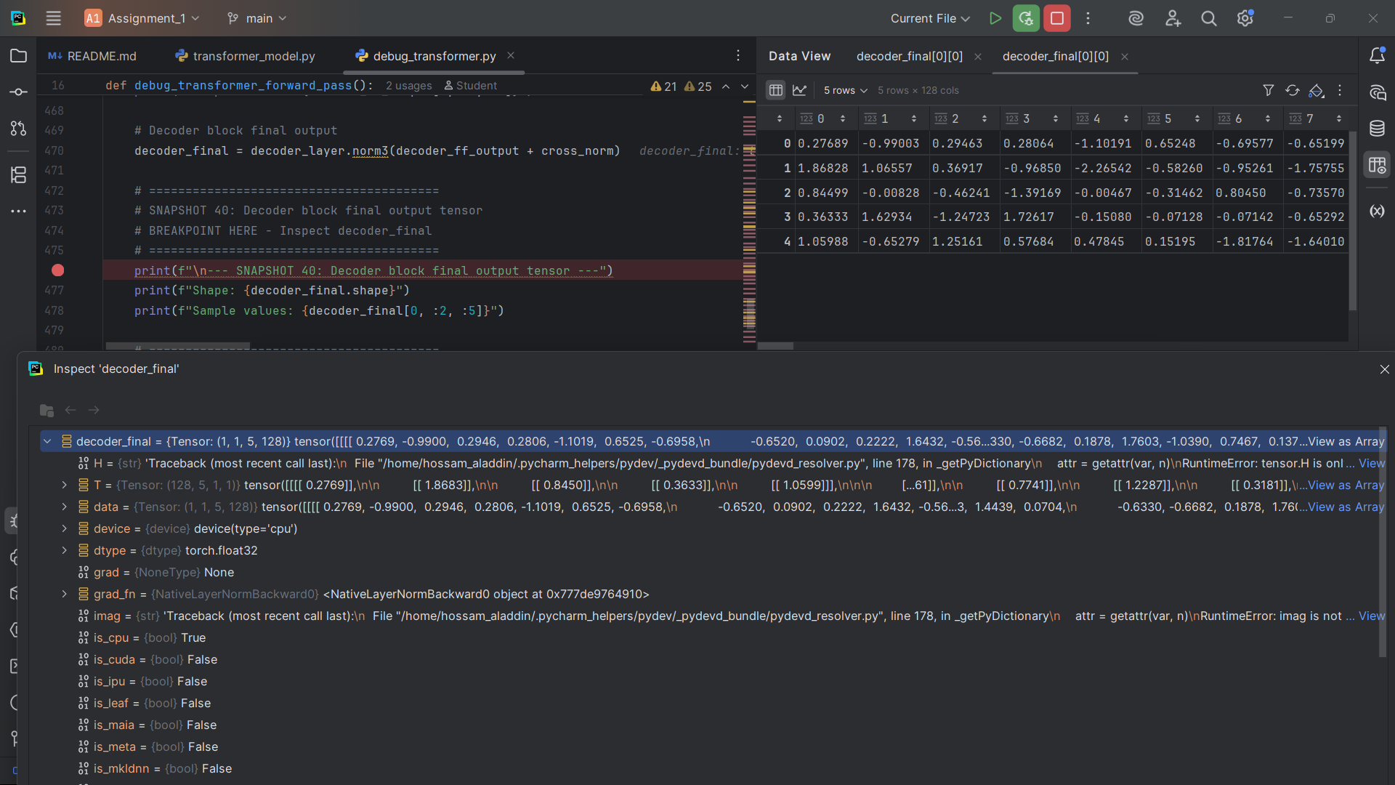]

**Snapshot #42 – Logits after final linear projection**

**Expected Shape**: (1, 1, 5, 1000)

**Expected Values**: Final vocabulary logits

**Explanation**: The final linear projection converts decoder output to vocabulary logits for each token.

[Snapshot #42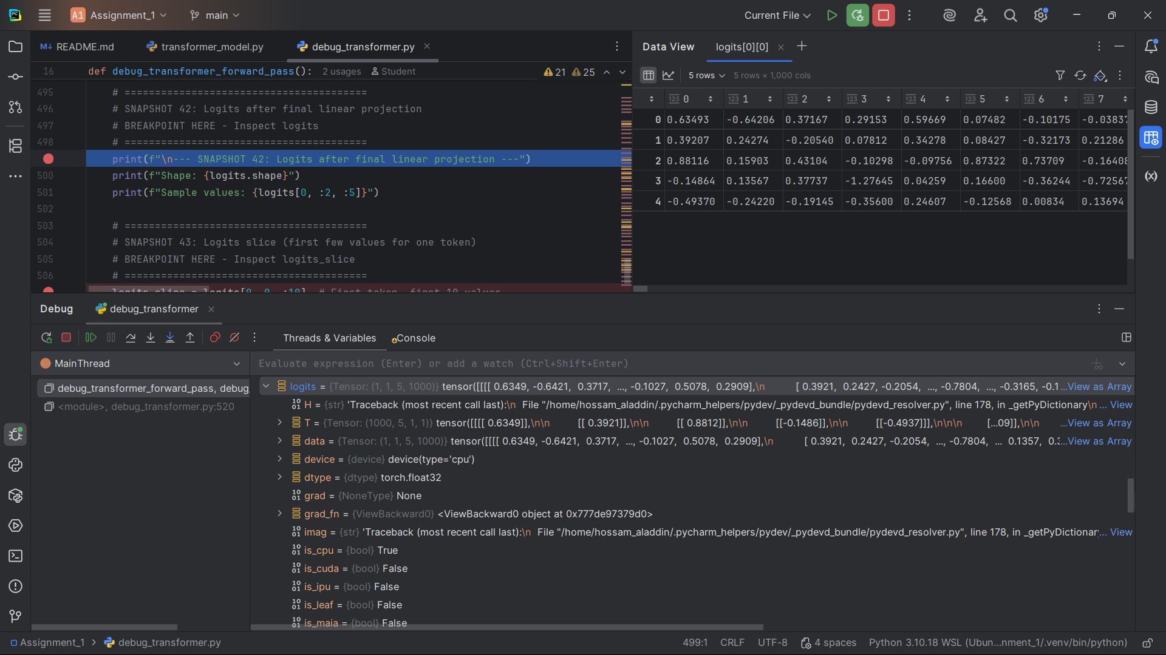]

**Snapshot #43 – Logits slice (first few values for one token)**

**Expected Shape**: (5, 1000)

**Expected Values**: First few values for each token

**Explanation**: A slice showing the first few logit values for each token in the sequence.

[Snapshot #43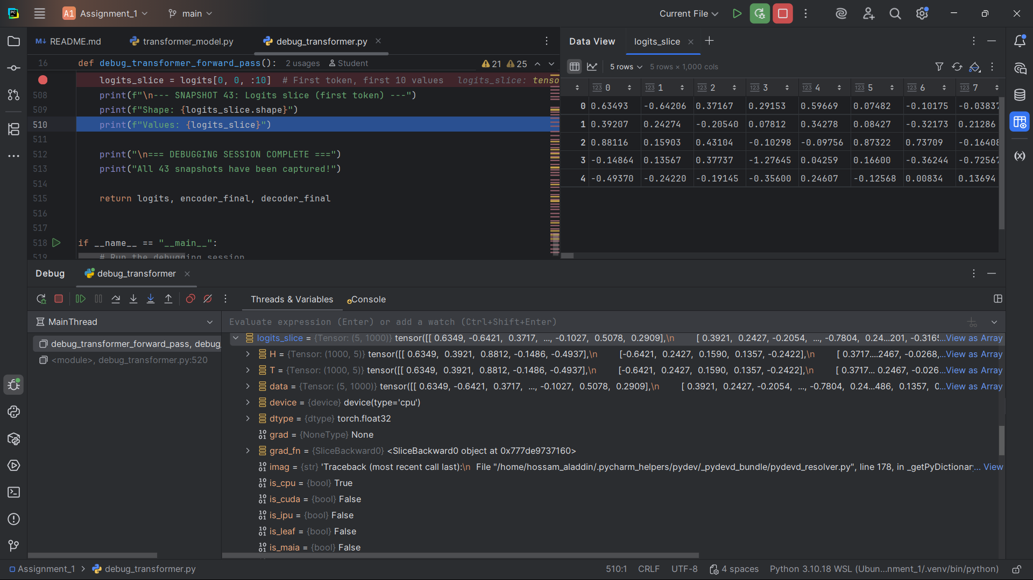]

**Answers to Guiding Questions**

**Question 1: What do each of the dimensions represent at embedding, attention, feed-forward, and output stages?**

**Answer**:

- **Batch dimension (1)**: Represents the number of sequences processed simultaneously

- **Sequence length (5)**: Represents the number of tokens in the input/target sequence

- **Embedding dimension (128)**: Represents the size of the dense vector representation for each token

- **Attention heads (4)**: Represents the number of parallel attention mechanisms

- **Head dimension (32)**: Represents the size of each attention head (128/4 = 32)

- **Feed-forward dimension (512)**: Represents the expanded dimension in the feed-forward network

- **Vocabulary size (1000)**: Represents the number of possible tokens in the vocabulary

**Question 2: Why do Q, K, V tensors have the same shape, and why are they split into heads?**

**Answer**:

- **Same shape**: Q, K, V all have shape (1, 5, 128) because they are all derived from the same input tensor through different linear transformations. They represent different aspects of the same information.

- **Split into heads**: Multi-head attention allows the model to attend to different types of relationships simultaneously. Each head can focus on different aspects (syntax, semantics, etc.), and splitting into heads increases the model's representational capacity.

**Question 3: What do the attention score matrices represent, and why must they be square?**

**Answer**:

- **Attention scores**: Represent the similarity/affinity between each query token and each key token. Higher scores indicate stronger attention.

- **Square matrices**: Must be square because each token in the sequence can attend to every other token in the sequence (including itself). For a sequence of length 5, we need a 5×5 matrix where each row represents one query token and each column represents one key token.

**Question 4: Why is masking necessary in the decoder, and how does the mask tensor enforce it?**

**Answer**:

- **Why masking**: During training, the decoder must not see future tokens to prevent cheating. It should only use information from previous tokens to predict the next token.

- **How mask works**: The causal mask is a lower triangular matrix where:

  - 1s allow attention to previous and current tokens

  - 0s (or -∞) prevent attention to future tokens

  - This ensures each token can only attend to itself and previous tokens

**Question 5: How do residual connections and layer normalization ensure consistency of shapes across blocks?**

**Answer**:

- **Residual connections**: Add the input tensor to the output tensor, requiring both to have the same shape. This ensures the output shape matches the input shape.

- **Layer normalization**: Normalizes across the feature dimension (last dimension) without changing the tensor shape, maintaining consistency.

- **Shape preservation**: Both operations preserve the tensor shape, allowing the same architecture to be stacked multiple times.

**Question 6: Why must the embedding dimension remain constant through all layers?**

**Answer**:

- **Consistency**: All layers must work with the same embedding dimension to maintain compatibility

- **Residual connections**: Require input and output to have the same shape

- **Multi-head attention**: Splits the embedding dimension into heads, so the total must remain constant

- **Architecture design**: Allows the same layer to be repeated multiple times in the stack

**Question 7: How does the final projection connect decoder output to vocabulary logits?**

**Answer**:

- **Linear transformation**: The final projection is a linear layer that maps from embedding dimension (128) to vocabulary size (1000)

- **Purpose**: Converts the continuous vector representation back to discrete token probabilities

-**Process**: Each position in the sequence gets a vector of 1000 logits, representing the probability of each vocabulary token

- **Output**: The logits can be converted to probabilities using softmax for token prediction

---

**Conclusion**

**What did you learn about Transformer architecture?**

**I understood that the Transformer is mainly built on an encoder-decoder structure, and the most important part is the multi-head self-attention. It allows the model to look at all parts of the input at the same time and capture relationships even if the tokens are far apart. I also learned how positional encoding helps the model keep track of the order of tokens.**

**What insights did you gain about attention mechanisms?**

**I realized that attention works like a weighting system, giving different importance to tokens when forming new representations. The concept of queries, keys, and values made it clear how the model decides what’s relevant. Debugging step by step showed me exactly how scores are calculated, then softmax is applied, and finally the weighted sum is produced.**

**How did debugging help your understanding?**

**Debugging forced me to slow down and see what happens at every stage. Instead of just looking at formulas, I watched the tensors change from embeddings, to attention scores, and then to the outputs. That made the forward pass of the Transformer much clearer.**

**What was most surprising or interesting?**

**The most surprising thing was how small changes in the attention weights can completely change the final representation. It showed me how powerful and sensitive the attention mechanism really is. I also found it interesting that even though the architecture looks complicated, when I broke it down step by step in debugging, each part was logical and easy to understand.**